Q1) Write two different queries that would produce all orders taken on october 3 rd or 4 th, 1990.
Ans:
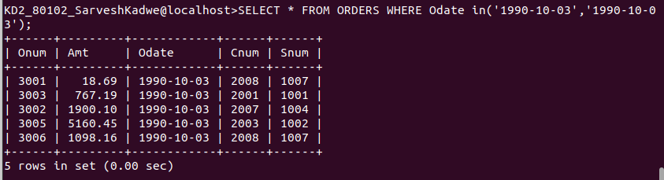
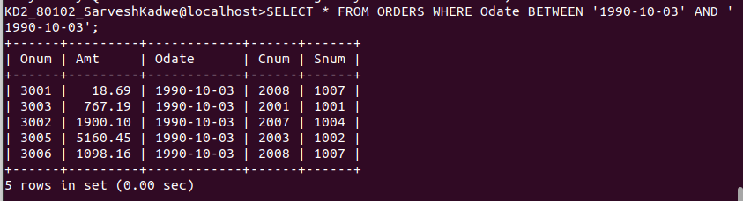

Q2) Write a query that Selects all of them of the customers serviced by peel or motika.
Ans:

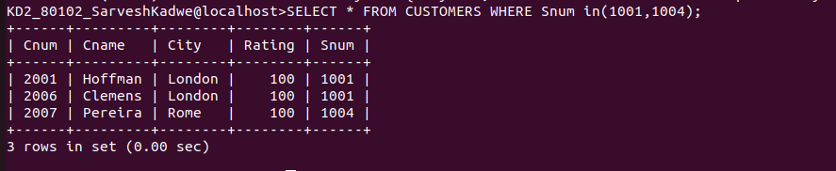

Q3) Write a query that will produce all the customers whose names begin with a letter from ‘A’ to ‘G’.
Ans:

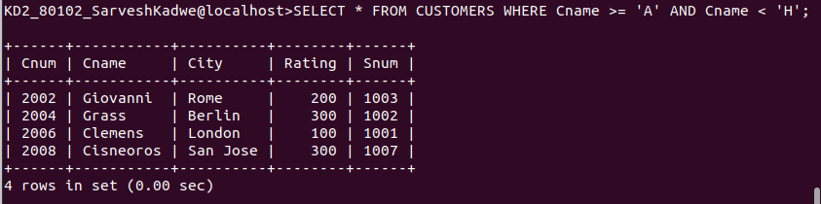

Q4) Write a query that selects all customers whose names begin with letter ‘C’.
Ans:
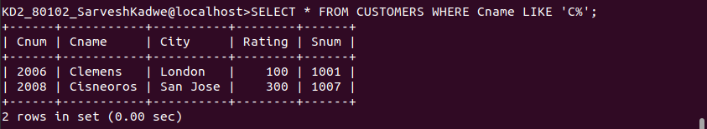

Q5) Write a query that selects all orders except those with zeroes or NULLs in the amt field.
Ans:
