ASSIGNMENT 10

Q1) Write a query that produces all pairs of salespeople who are living in the same city. Exclude
combinations of salespeople withn themselves as well as duplicate rows with the order reversed.

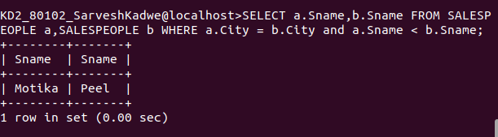

Q2) Write a query that produces the name and cities of all customers with the same rating as
Hoffman

