ASSIGNEMENT 14
Q1) Write a command that puts the following values, is their given order, into the salespeople
table: city San Jose, name - Blanco, comm - NULL, cnum -1100.

Q2) Write a command that removes all orders from customer Clemens from the Orders
table.
Q3) Write a command that increases the rating of all customers in Rome by 100.

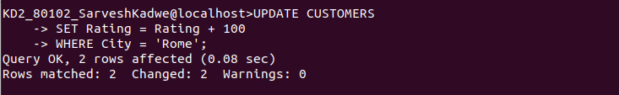

Q4) Salesperson Serres has left the company. Assign her customers to Motika.
