Q1) Write a select command that produces the order number, amount, and date for all rows in the Orders table.
Ans :

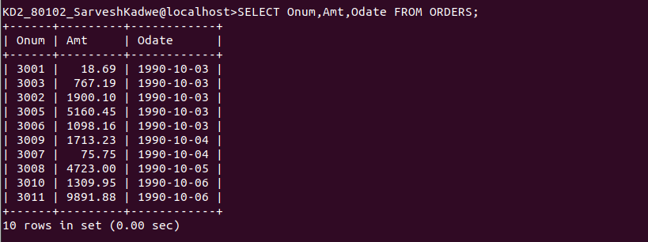

Q2) Write a query that produces all rows from the Customers table for which the salesperson's number IS 1001.

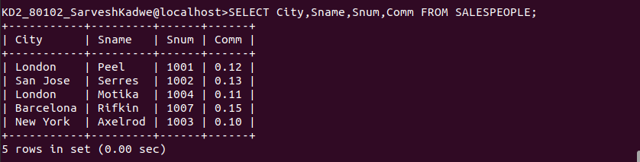
Q3) Write a query that displays the Salespeople table with the columns in the following order: city, sname, snum, comm.
Ans:

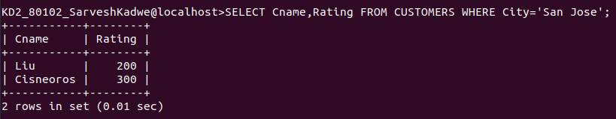
Q4) Write a select command that produces the rating followed by the name of each customer in San Jose.
Ans:

