ASSIGNMENT - 12

Q1) Write a query that selects all customers whose rating are equal to or greater
than any of ‘Serres’.
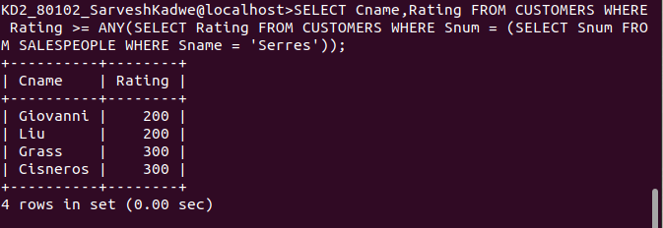
Alternate Solution

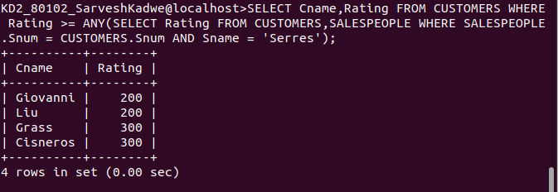

Q2) Write a query using any or all that will find all salespeople who have no
customers located in their city.
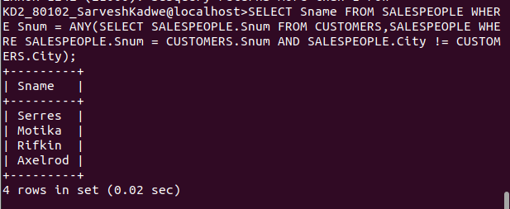

Q3) Write a query that selects all orders for amount greater than any for the
customers in London.
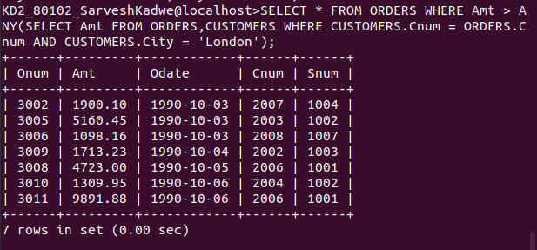

Q4) Write the above query using min or max.

