Assignment 2

1 Sort by Date

2 Sort by Size largest First

3 print Inode

4

ls CDAC

ls */

5.

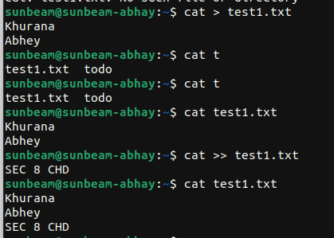

6.
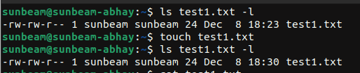
7.

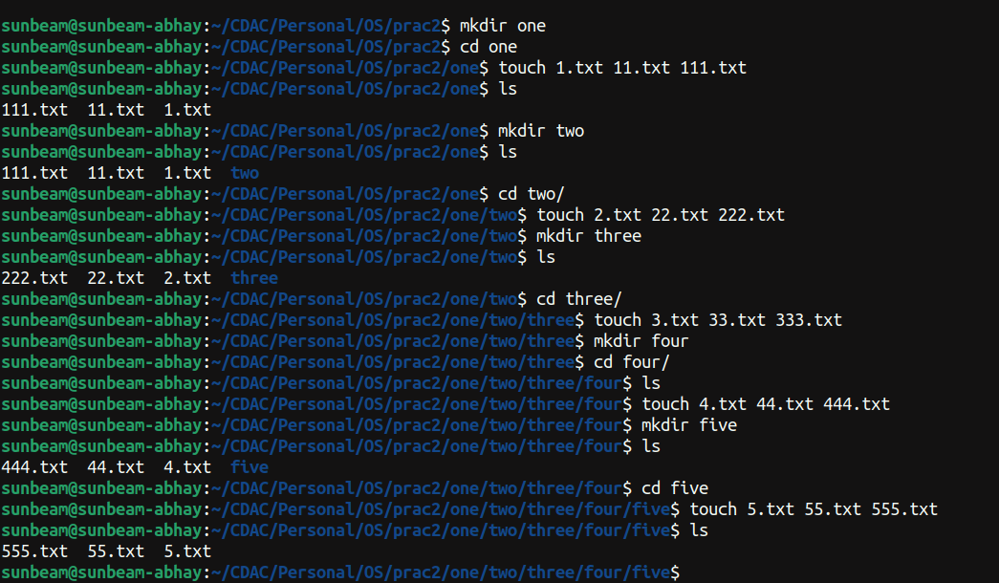
8 .

1, 2

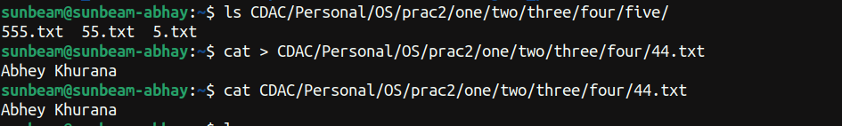
3,

4, 5

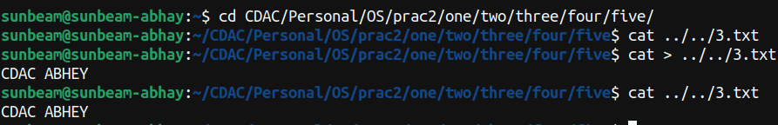
6

7

8 ,9

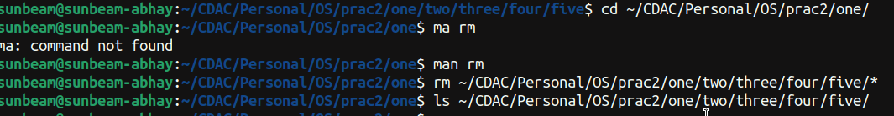
10

11

12
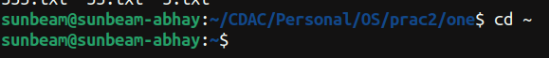
9.
