ASSIGNMENT NO 15
Q1 assume there is table call multicast ,with alll of the same column defination as salespeople write a command that insert all salespeole with more than one customer into this table
CREATE TABLE Multicast AS SELECT * FROM SALESPEOPLE WHERE SNUM IN (SELECT SNUM FROM CUSTOMER GROUP BY SNUM HAVING COUN
T(SNUM)>1);
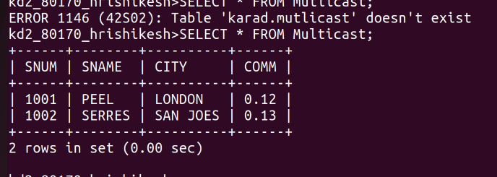
Q2 write the command that delete all customer with no current oders
kd2_80170_hrishikesh>DELETE CUSTOMER WHERE CNUM=ANY (SELECT CNUM FROM ODERS WHERE CNUM NOT IN (SELECT CNUM FROM CUSTOMER));

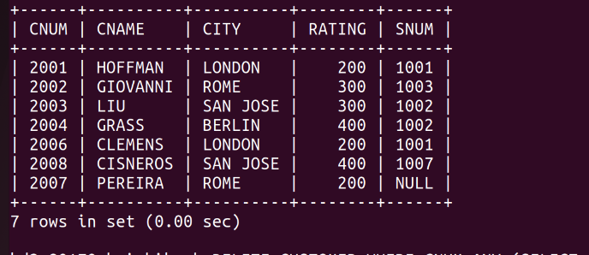
H

Q3 WRITE A COMMAND THAT INCRESE BY TWENTY PERCENT THE COMISION OF ALL SALESPEOPLE WITH TOTAL ORDER ABOVE RS 3000
