Assignment no 13
Q 1 create union of two queries that shows the names ,cities,and rating of all customer
with rating of al customer those with rating of 200 or greater will also have the word “high rating “ while the other will have the word “low Rating” .

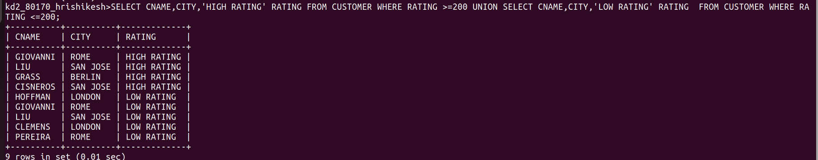
Q2 write command that produce the name and number of each salesperson and each customer with more than one current order the result in alphabetical order
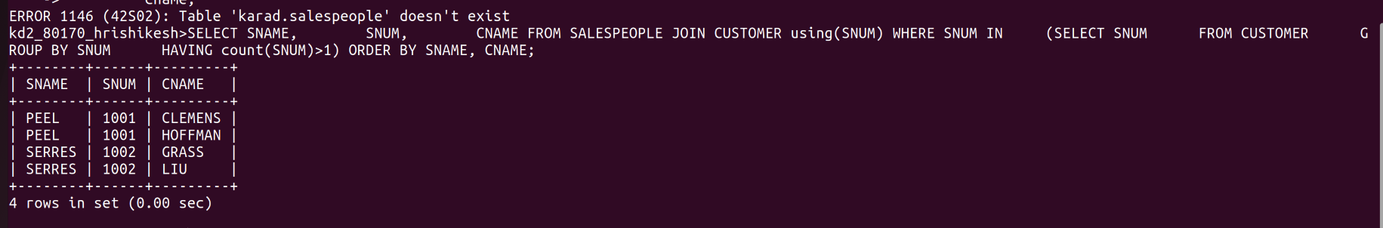

Q3 form a union of three querry have the first select the sums of all salespeople in san jose ;the second ,the cnums of all customer in san jose and the third the onums of all order on octomber 3. retain dulpicate between the last two querise but eliminate ay redundancies between either of them and first
