Assignment – 11

Que1) Write a query that uses a subquery to obtain all orders for
the customer named Cisneros. Assume you do not know
his customer number(cnum).

Ans)
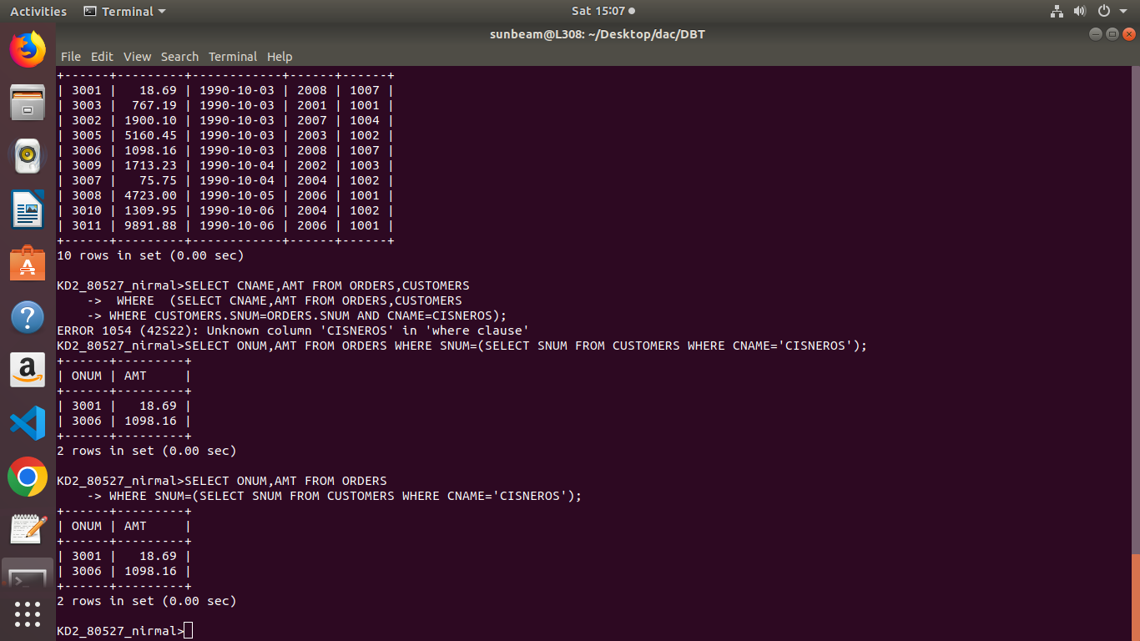

Que2) Write a query that produce the names and ratings of all
customers who have above-average orders.

Ans)
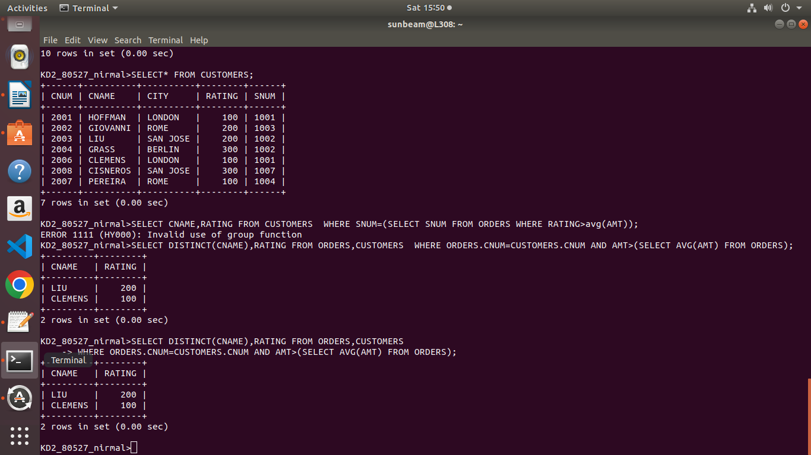

Que3) Write a query that selects the total amount in orders for
each salesperson for whom this total is greater than amount
of the largest order in the table .
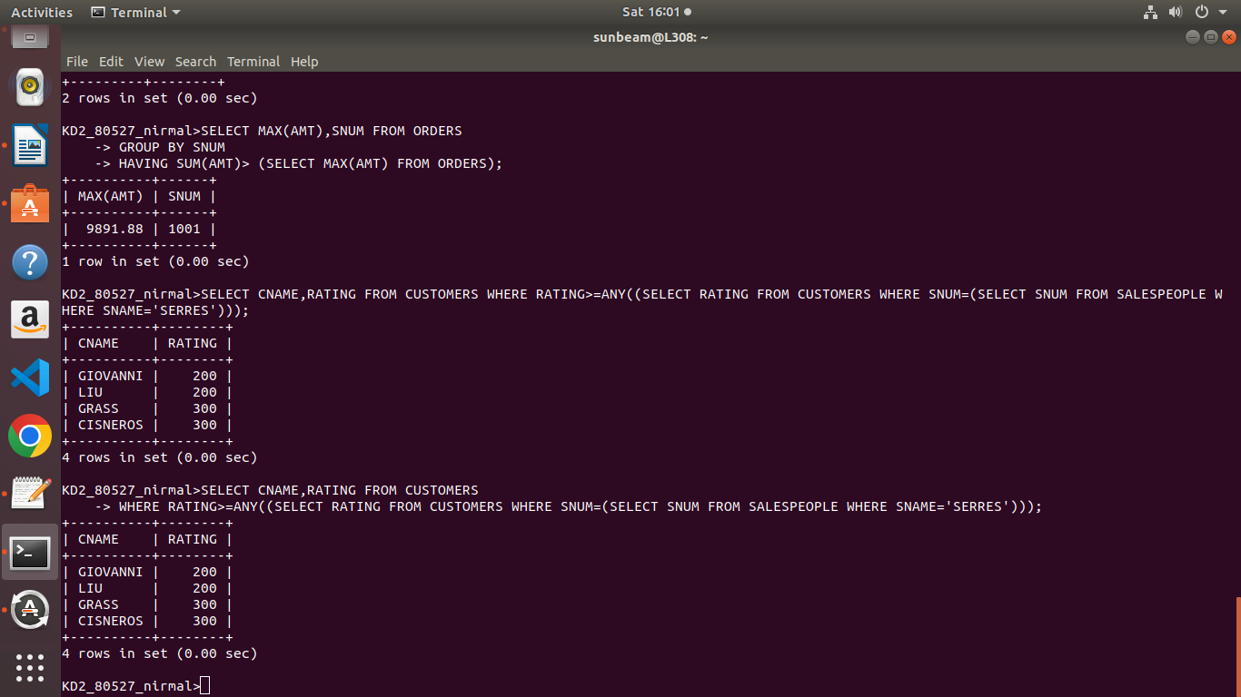
Ans)

