Assignment – 13

Que1) Create a union of two queries that shows the names , cities,
and ratings of all customers. Those with rating of 200 or
greater will also have the words “High Rating” , while
others will have the words “Low Rating”.

Ans)

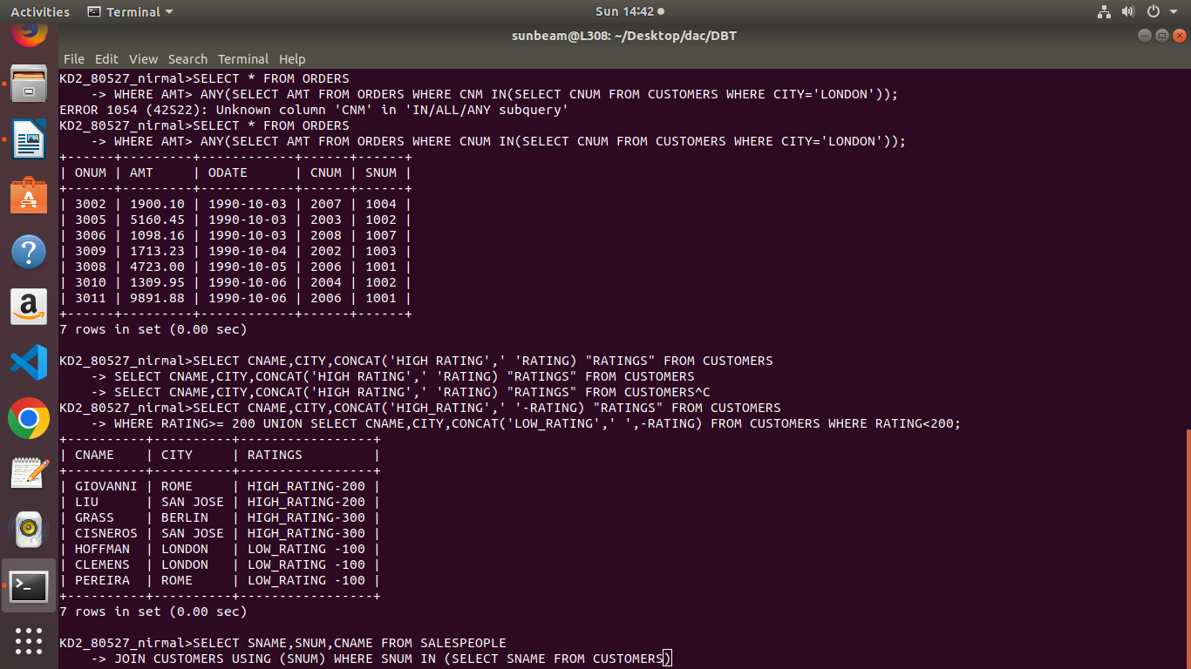

Que2) Write a command that produces the name and number of
each salesperson and each customers with more than one
current order. Put the results in alphabetical order.

Ans)

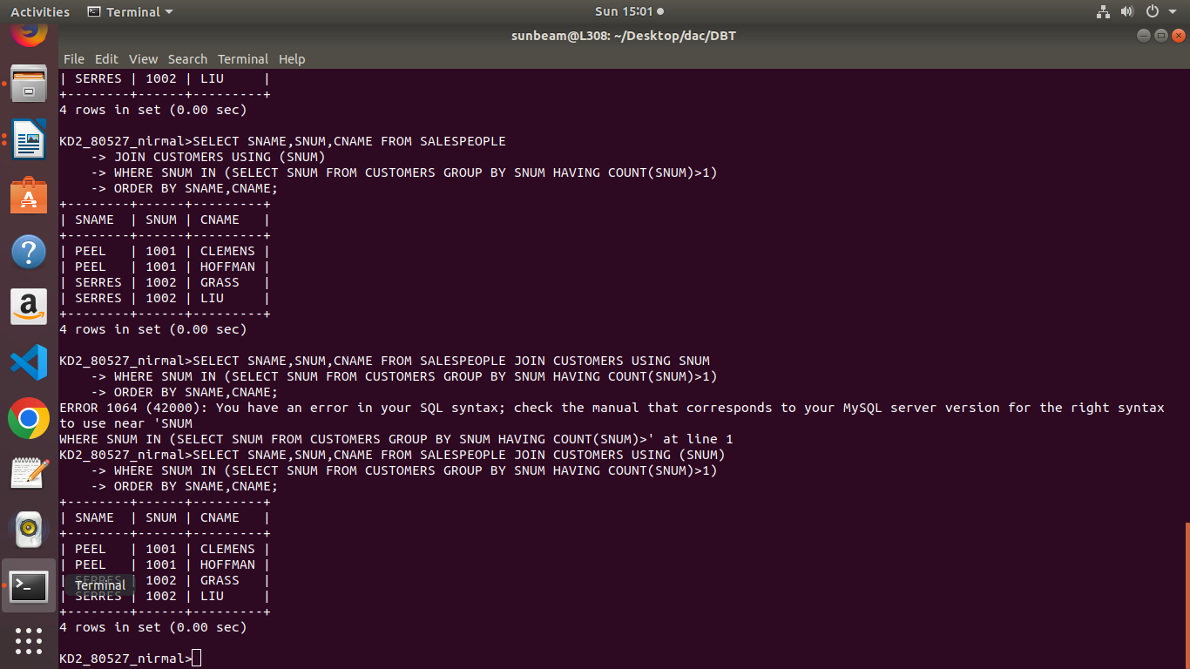

Que3) From a union of three querries. Have the first select the
snums of all salespeople in San jose;the second ; and the
third the onums of all orders on October 3. Retain
duplicates between the last two queries but eliminate any
rebundancies between either of them and the first.

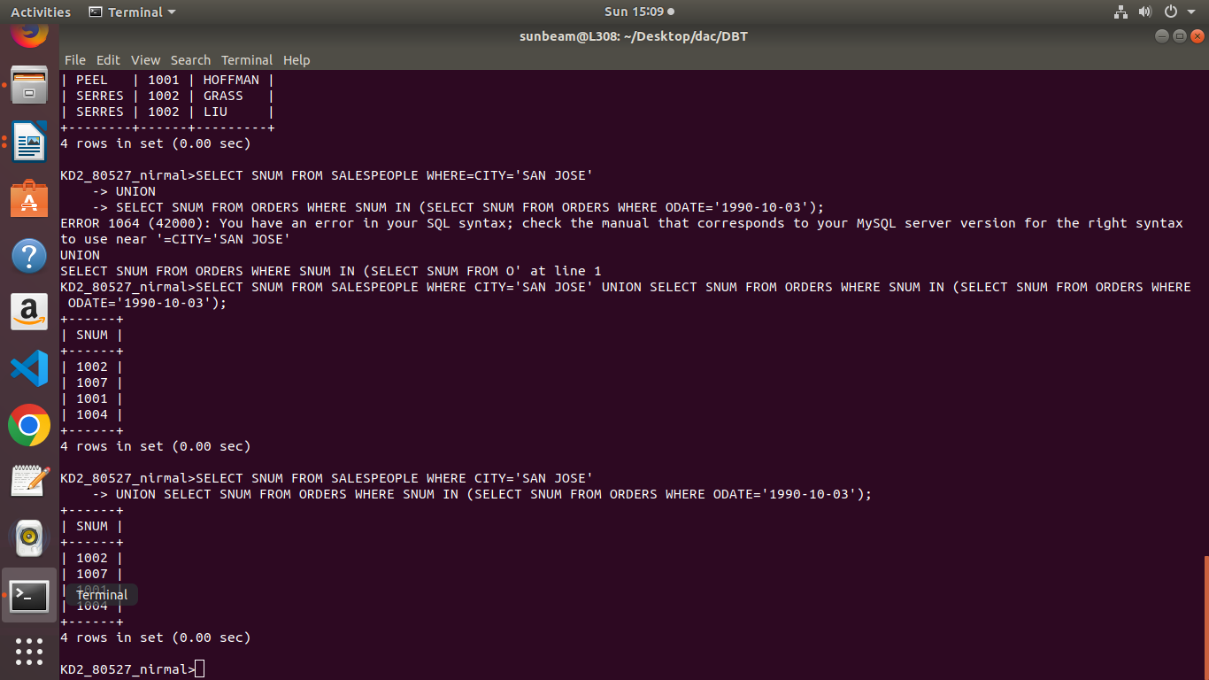
Ans)

