Assignment – 1

Que 1) Create following table with given structures amd insert sample data as specified :-

A) SALESPEOPLE
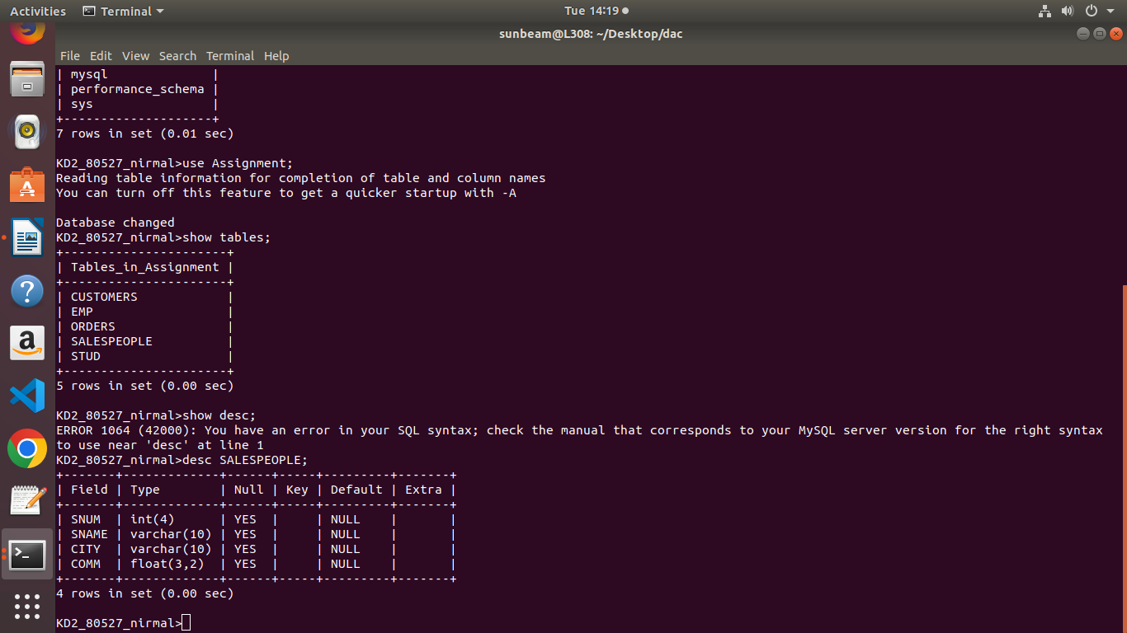

Inserted sample data for SALESPEOPLE:
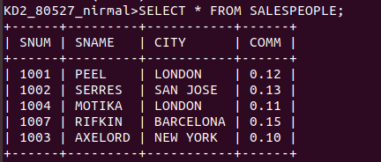

B) CUSTOMERS:-
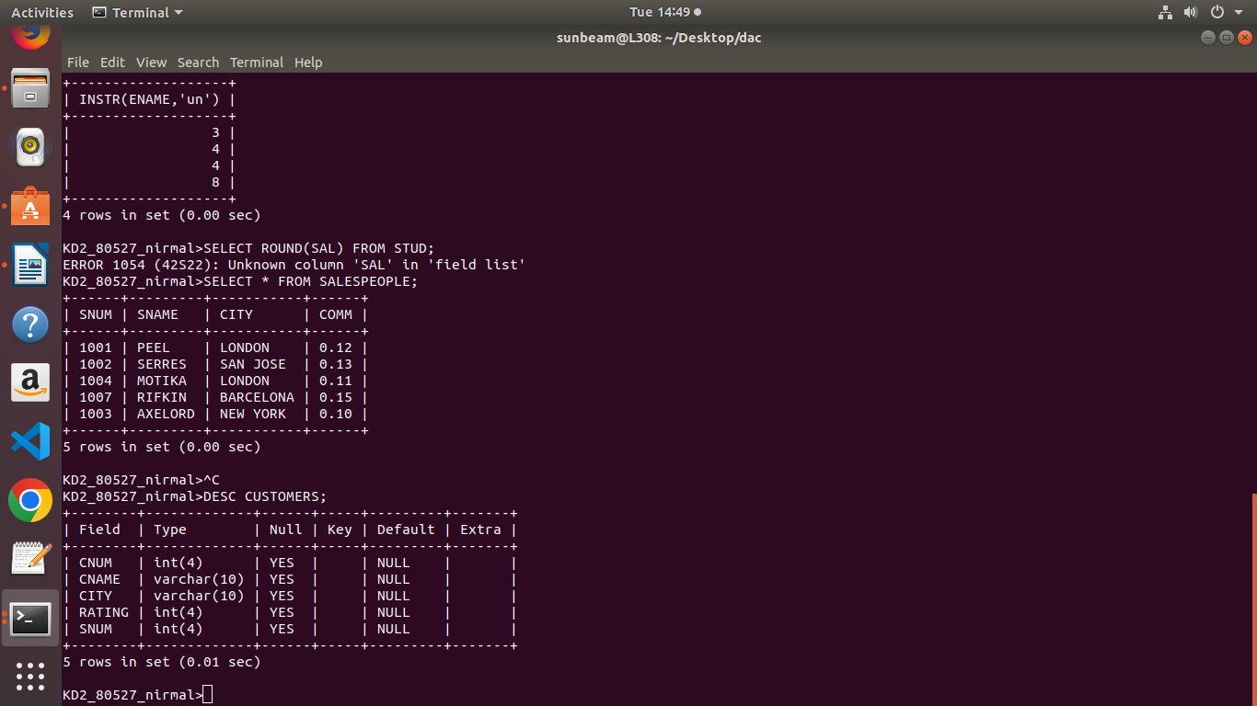

Insterted sample data for CUSTOMERS
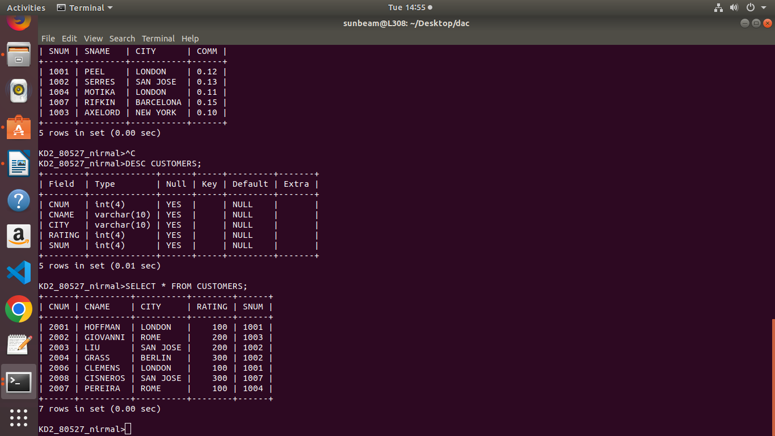

C) ORDERS
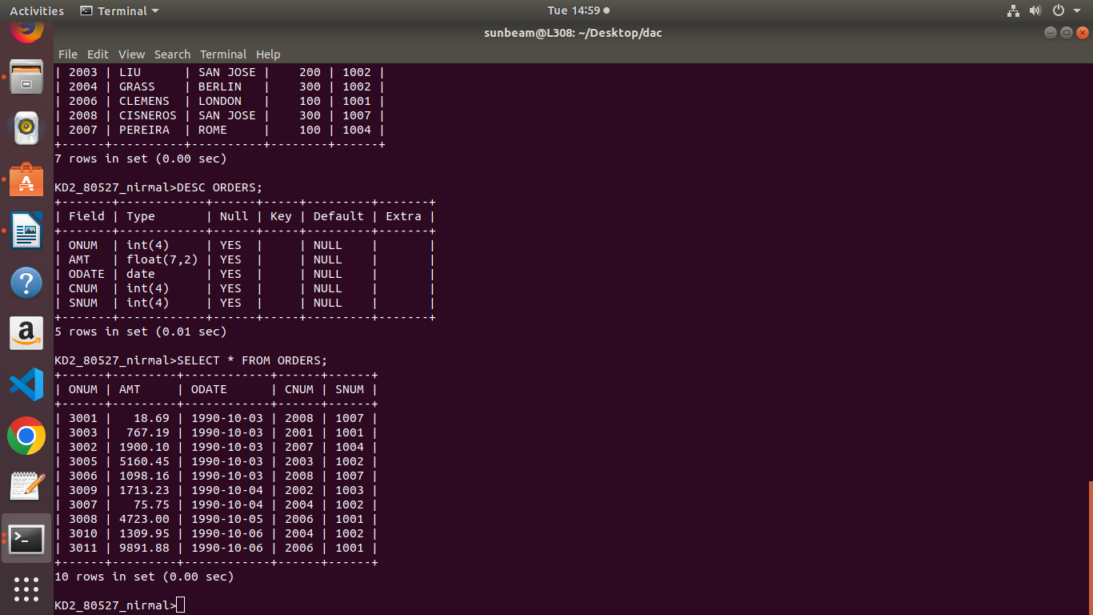

Insterted sample data for ORDERS

