Assignment – 4

Que1) Write a select command that produces the order
number,amount,and date for all the rows in the orders tables ?

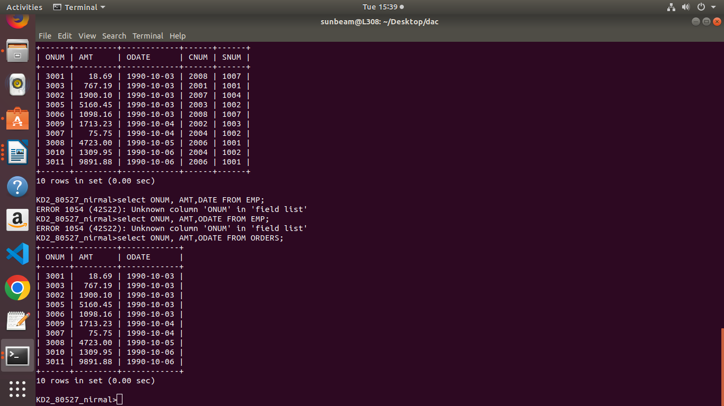
Ans) SELECT ONUM,AMT,ODATE FROM ORDERS;

Que2) Write a query that produces all rows from the customers table for which the salesperson’s number is 1001.

Ans) SELECT * FROM CUSTOMERS
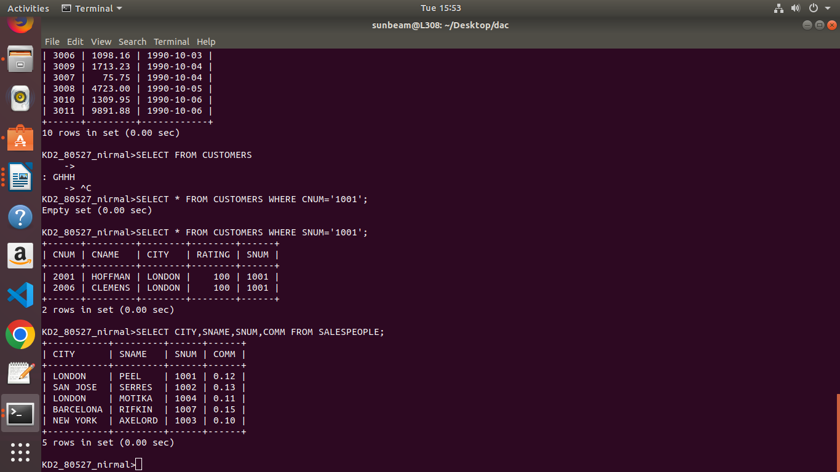
WHERE SNUM=’1001’;

Que3) Write a query that displays the Salespeople table with the
columns in the folling order: city, sname, snum, comm.

Ans) SELECT CITY,SNAME,SNUM,COMM FROM
SALESPEOPLE;

Que4) Write a select command that produces the rating followed by the name of each customer in San Jose .

Ans) SELECT RATING,CNAME FROM CUSTOMERS
WHERE CITY='SAN JOSE';
