Assignment – 5

Que1) Write a query that will give you all orders for more than
Rs. 1000.

Ans) SELECT * FROM ORDERS WHERE AMT>1000;
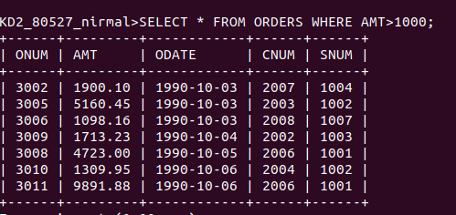

Que2) Write a query that will give you the names and cities of
all salespeople in london with a commision above .10 .

Ans) SELECT SNAME,CITY FROM SALESPEOPLE
WHERE COMM>.10 AND CITY='LONDON';
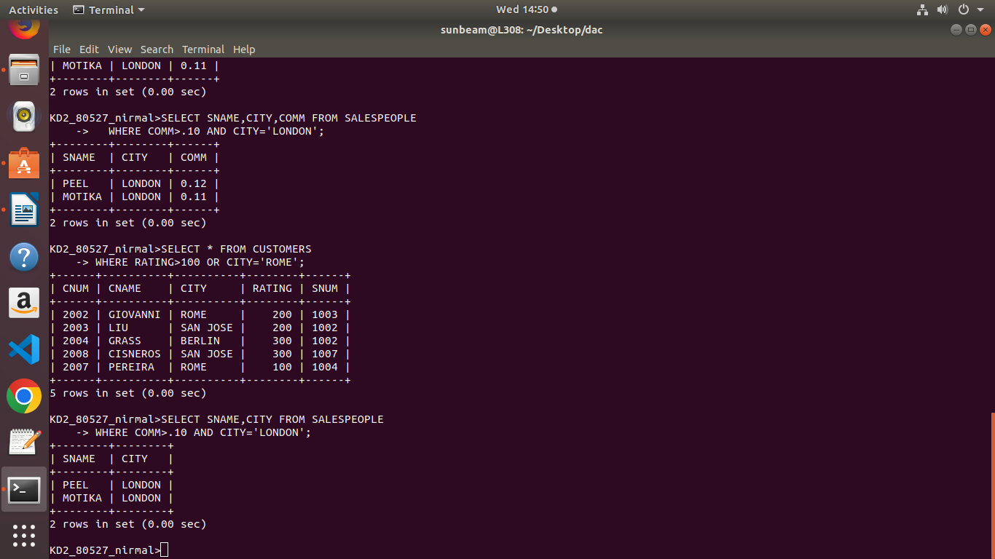

Que3) Write a query on the customers table whose output will
exclude all customers with a rating <= 100, unless they are
located in Rome.
Ans) SELECT * FROM CUSTOMERS
WHERE RATING>100 OR CITY='ROME';
Que4) What will the output from the following query?

SELECT * FROM ORDERS
WHERE ( AMT < 1000 OR NOT (ODATE = ‘1990-10-03’ AND
CNUM > 2003));
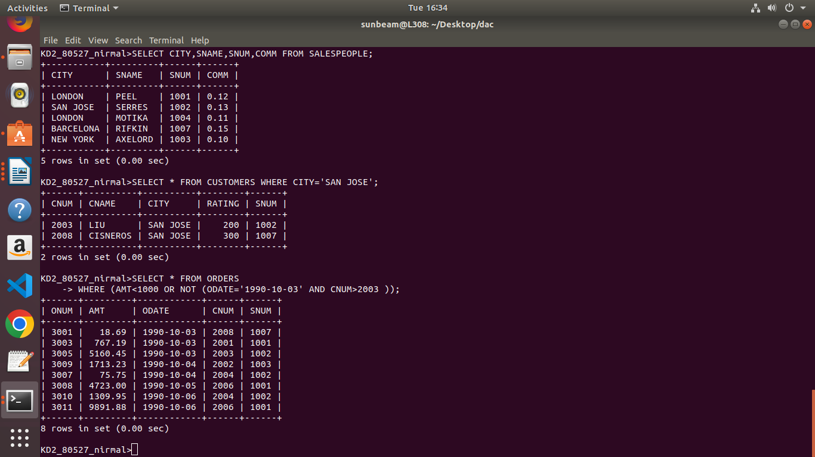
Ans)

Que5) What will the output from the following query?

SELECT * FROM ORDERS
WHERE NOT ( (ODATE = ‘1990-10-03’ OR SNUM > 1006) AND
AMT>=1500);
Ans)
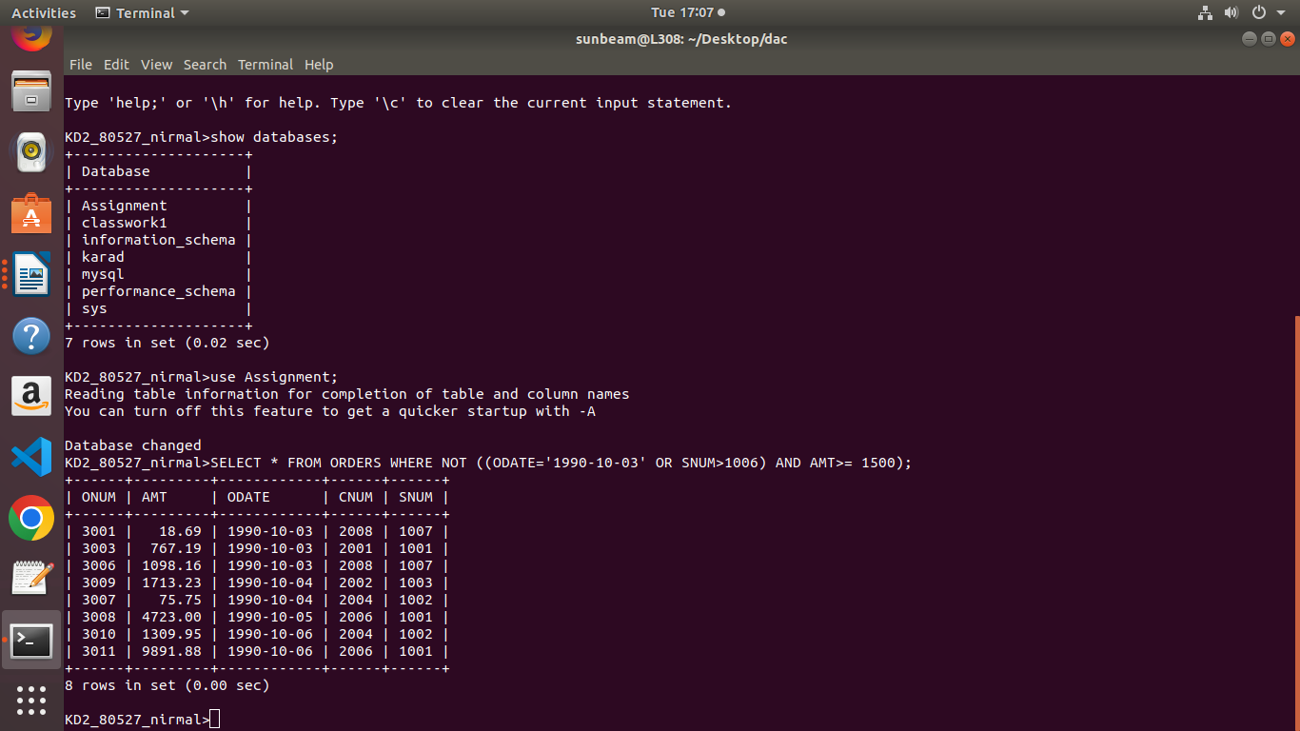

Que6) What is the simpler way to write this query?

SELECT SNUM,SNAME,CITY,COMM FROM SALESPEOPLE
WHERE (COMM> .12 OR COMM< .14);

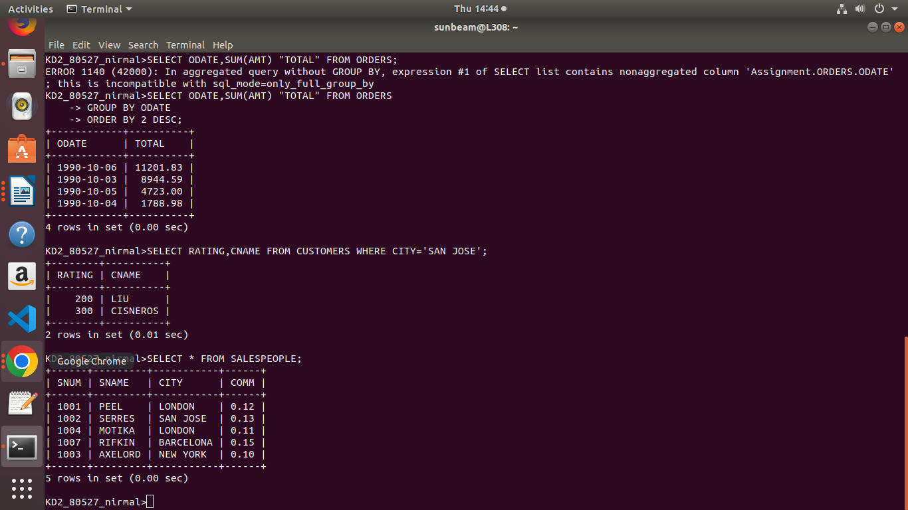
ANS) SELECT * FROM SALESPEOPLE;

