Assignment – 6

Que1) Write two different queries that would produce all orders
taken on October 3rd or 4th ,1990.

Ans) 1. SELECT * FROM ORDERS
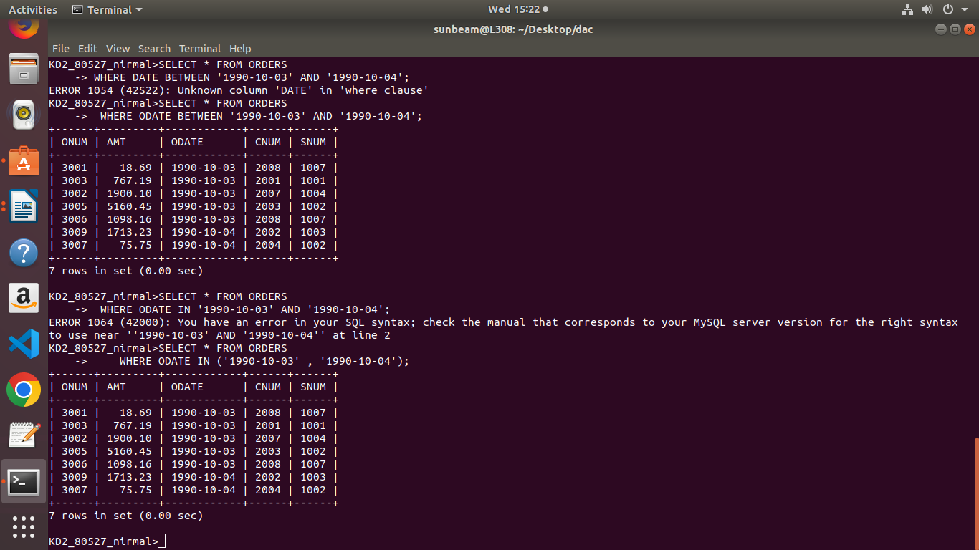
WHERE ODATE BETWEEN '1990-10-03' AND '1990-10-04';

2. SELECT * FROM ORDERS
WHERE ODATE IN ('1990-10-03' , '1990-10-04');

Que2) Write a query that selects all of the customers serviced by
Peel or Motika .
Ans)
SELECT CNAME FROM CUSTOMERS
WHERE SNUM = '1001' OR SNUM ='1004';
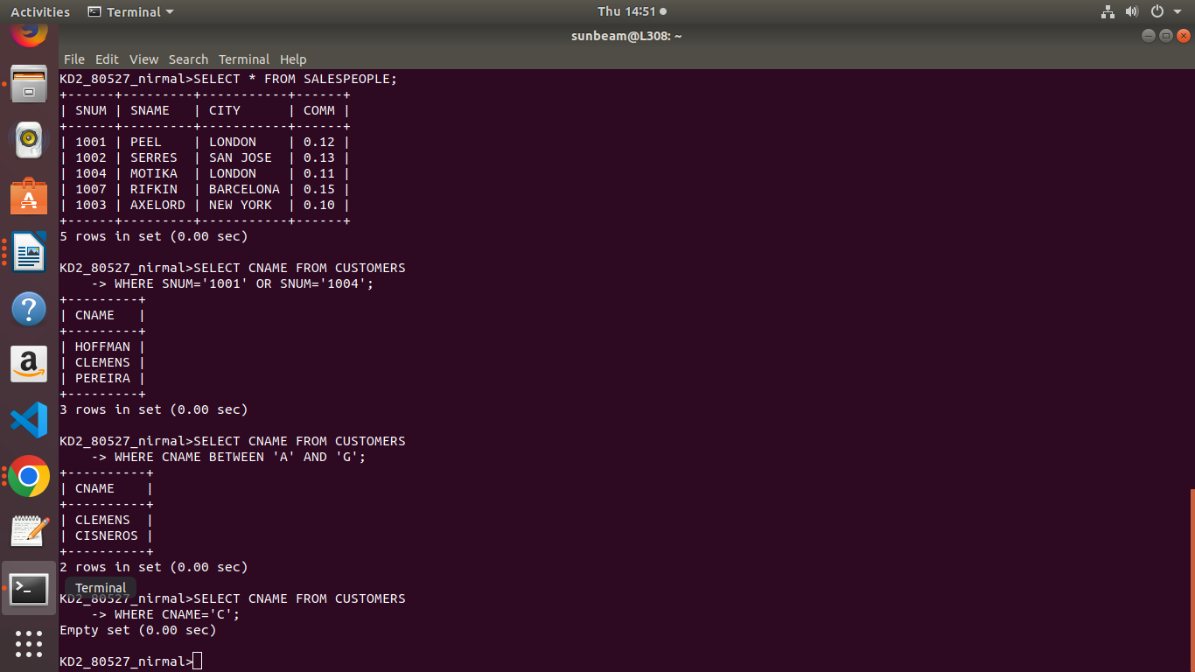

Que3) write a query that will produce all the customers whose name begin with a letter from ‘A’ to ‘G’.

Ans) SELECT CNAME FROM CUSTOMERS
WHERE CNAME BETWEEN 'A' AND 'G';

Que4) Write a query that selects all customers whose names begin
with letter ‘C’.

Ans) SELECT * FROM CUSTOMER WHERE CNAME LIKE 'C%';

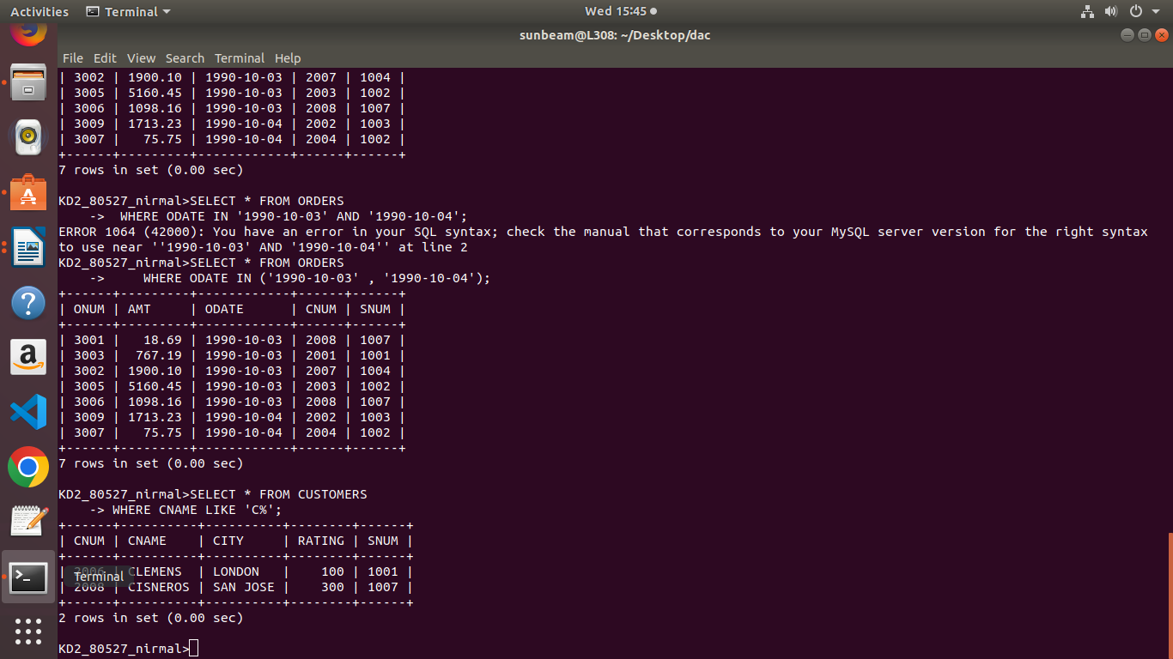

Que5) Write a query that selects all orders except those with
zeroes or nulls in amount field.

Ans) SELECT * FROM ORDERS
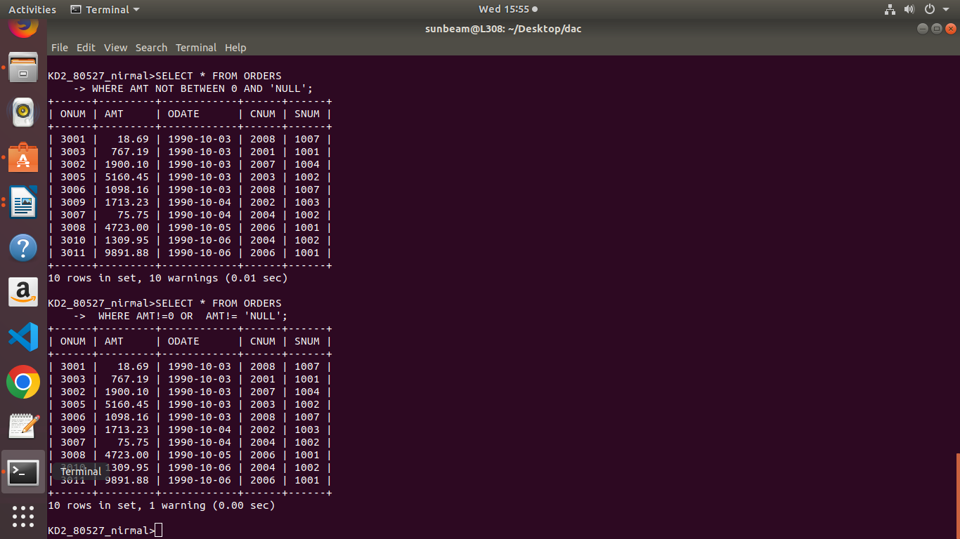
WHERE AMT NOT BETWEEN 0 AND 'NULL';

