Assignment – 7

Que1) Write a query that counts all orders for October 3.

Ans)
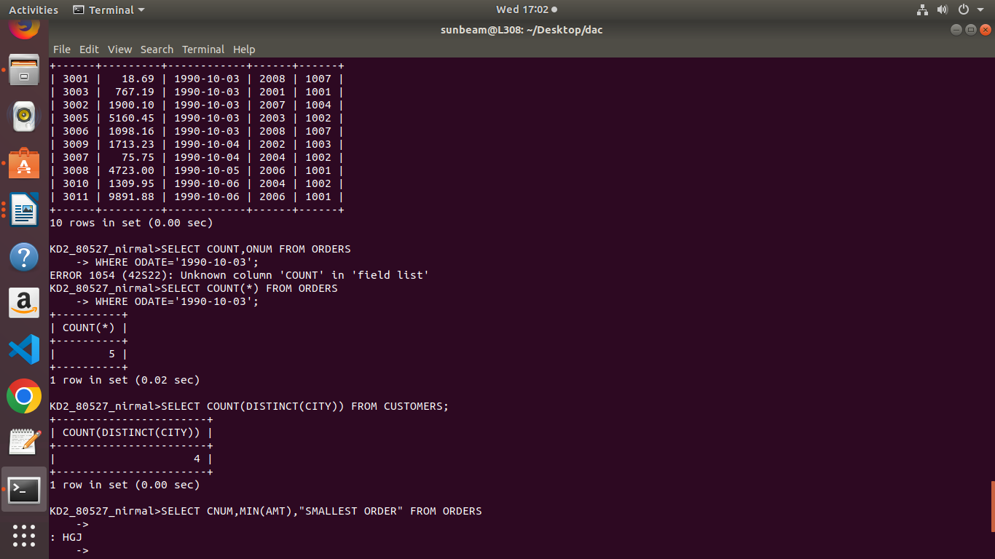

Que2) write a query that counts the no. Of different non null city
values in the customers table.

Ans)

Que3) Write a query that selects each customer’s smallest order.

Ans)
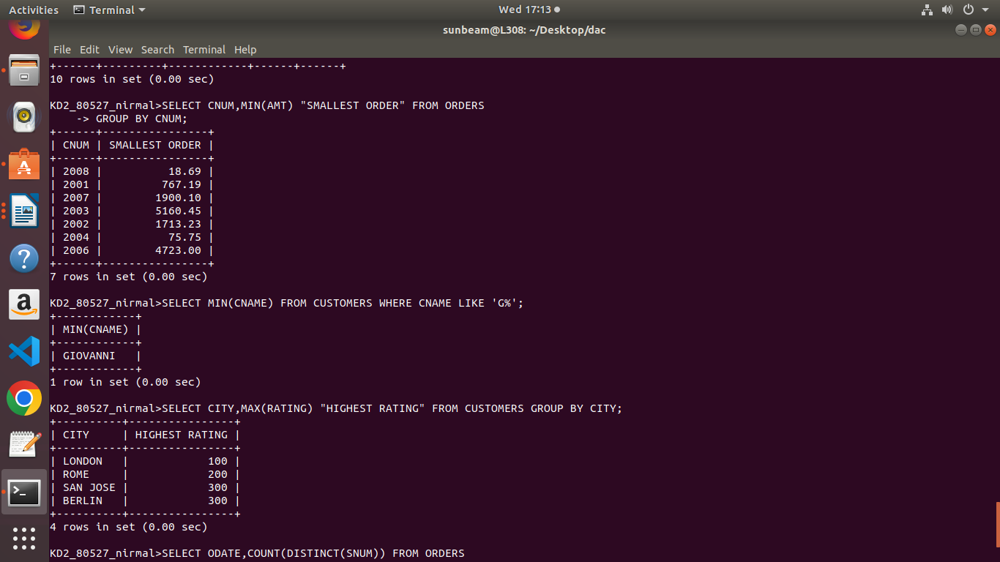

Que4) Write a query that selects the first customer,in alphabetical
order, whose name begins with G.
Ans)

Que5) Write a query that selects the highest rating in each city.

Ans)

Que6) write a query that counts the no. of salespeople regestering
orders for each day .(if a salesperson has more than one
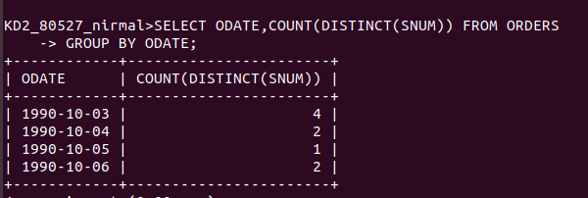
order on a given day, he or she shoud counted only once).
Ans)

