Assignment-8

Que1) Assume each salesperson has a 12% commision.
Write a query on the orders table that will produce the
order no. , the salesperson no. and the amount of the
salespersons commision for that order.
Ans)
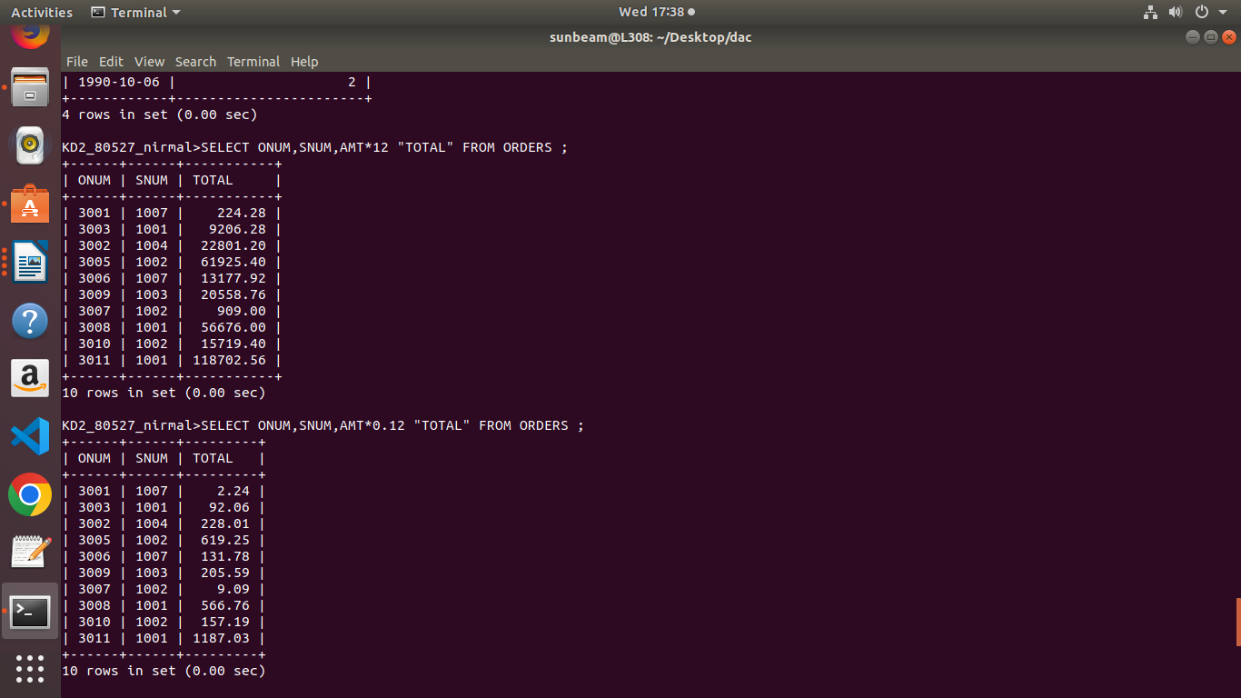

Que2) Write a query on the customers table that will find the
highest rating in each city. Put the output in theis form:
for city(city), the highest rating is:(rating)
Ans)
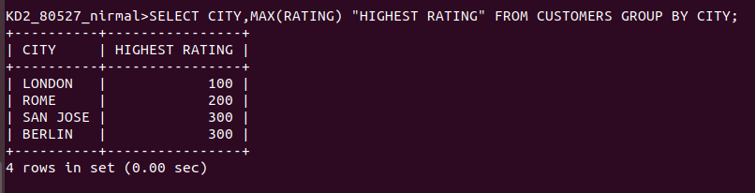

Que3) Write a query that lists customers in descending order of
rating. Output the rating field first , followed by the
customer’s name and number.
Ans)
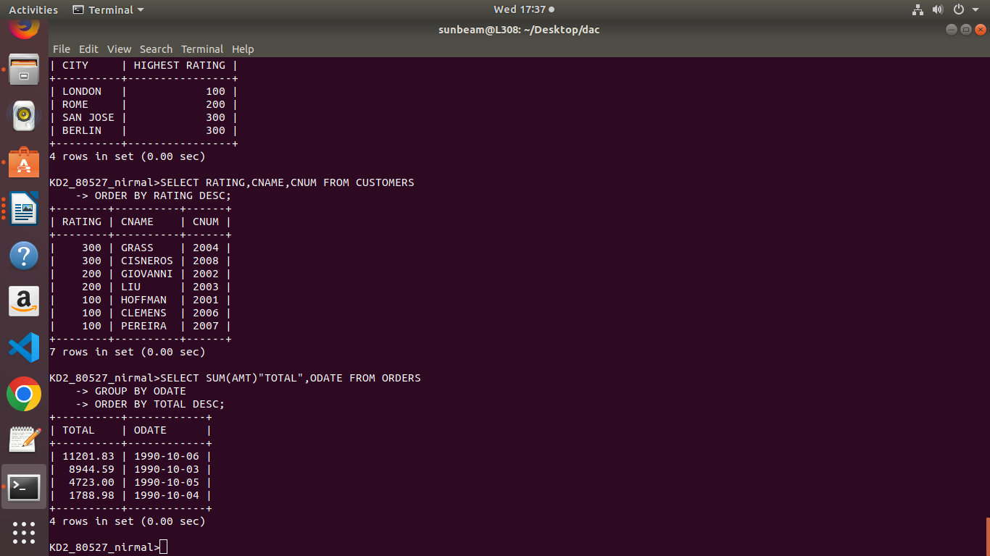

Que4) Write a query that totals the orders for each day and
places the result in descending order.
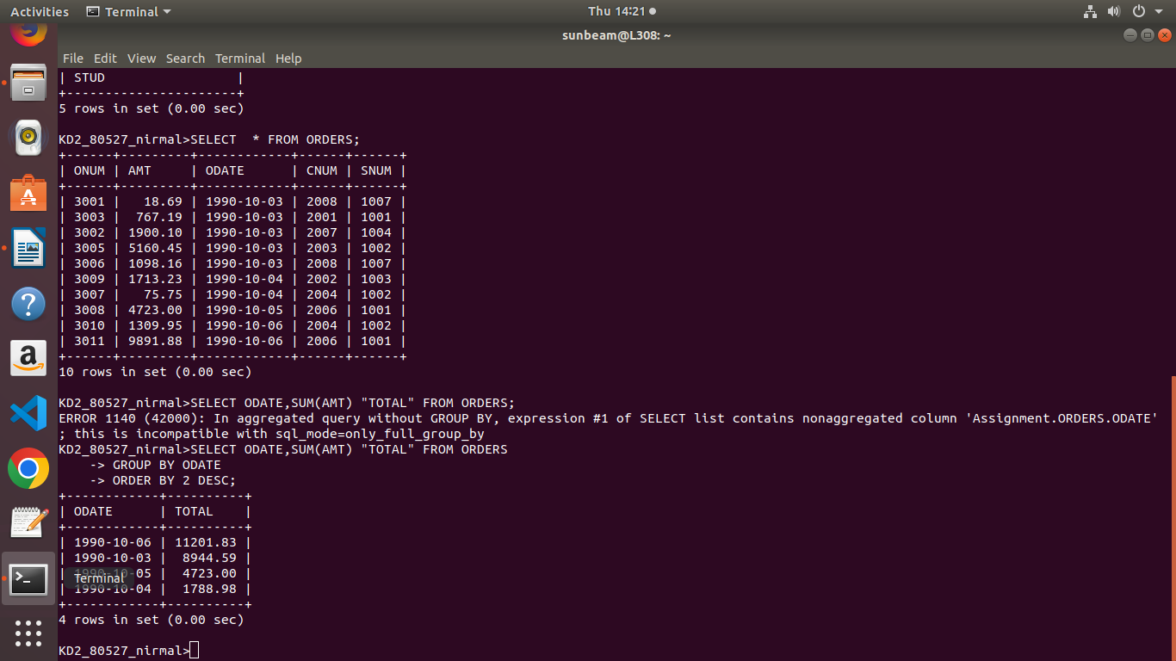
Ans)

