Assignment – 9

Que1) Write a query that lists each order number followed by the
name of customers who made the order .

Ans)
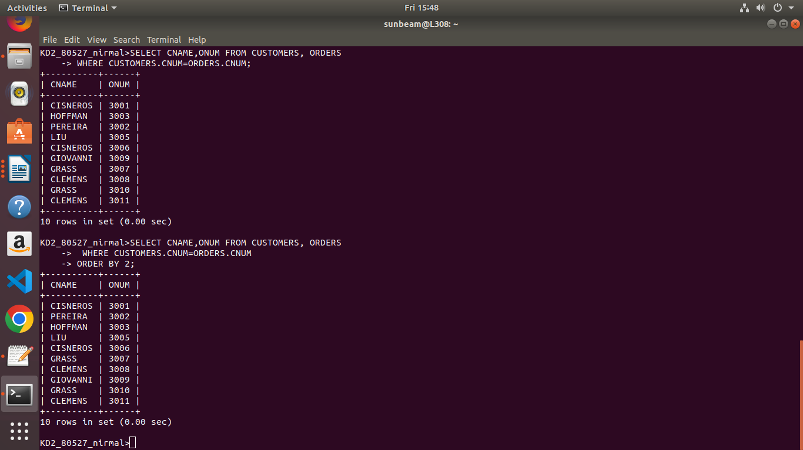

Que2) Write a query that gives the names of both the salesperson
and the customers for each order along with the order
number.

Ans)
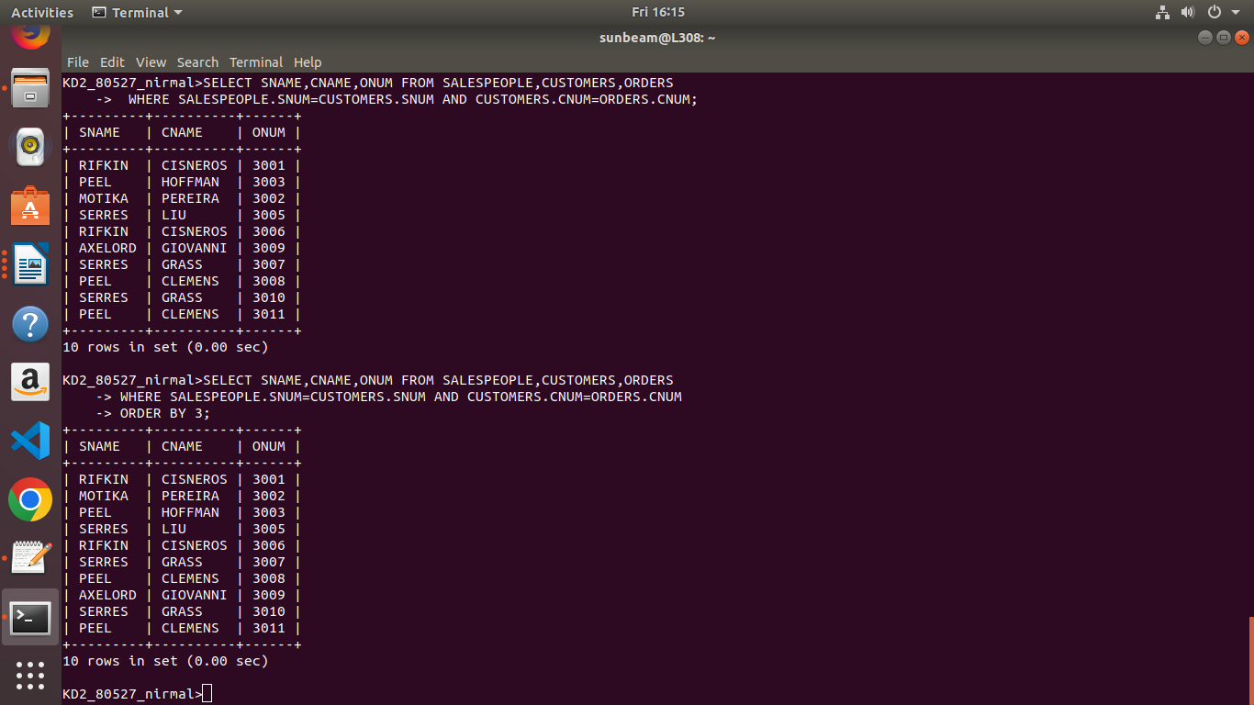

Que3) Write a query that produces all customers serviced by
salespeople with a commision above 12% . Output the
customer’s name,the salesperson’s name and the
salesperson’s rate of commision .

Ans)
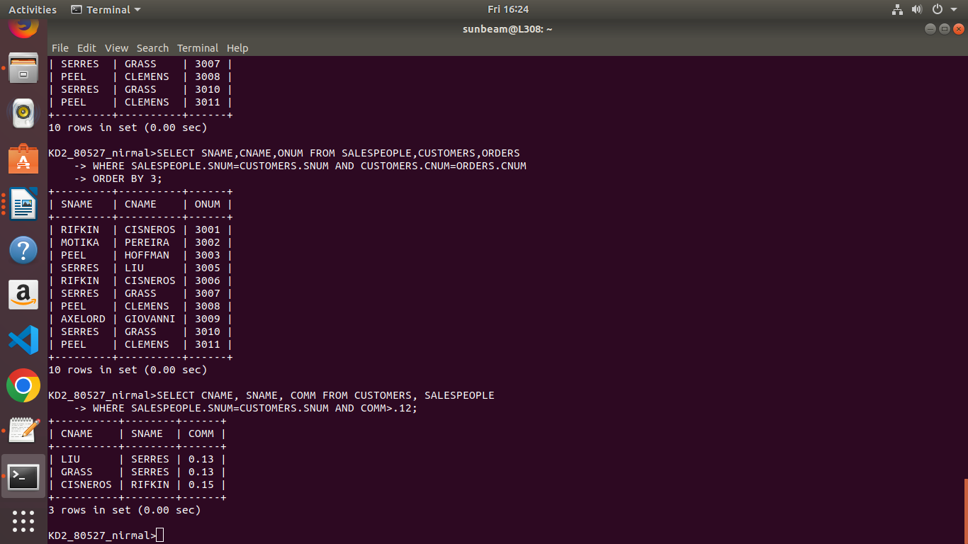

Que4) Write a query that calculates amount of Salesperson’s
commision on each order by a customer with a rating
above 100.

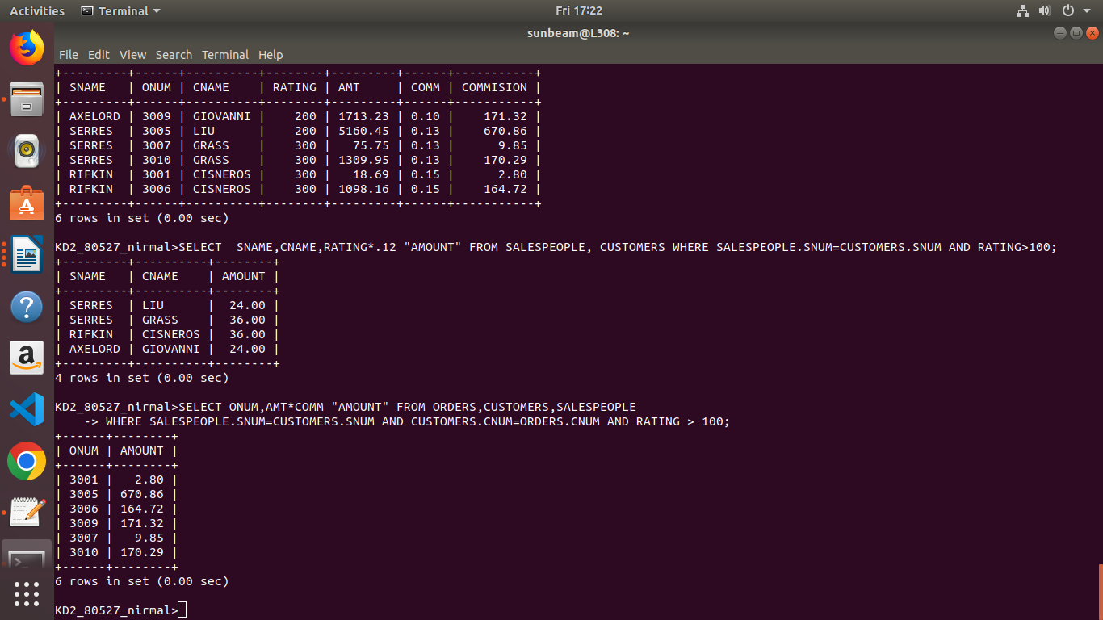
Ans)

