Assignment – 10

Que1) Write a query that qroduces all pairs of salespeople who
are living in the same city. Exclude combinations of
salespeople with thwmselves as well as duplicate rows
with the order reveresed.

Ans)
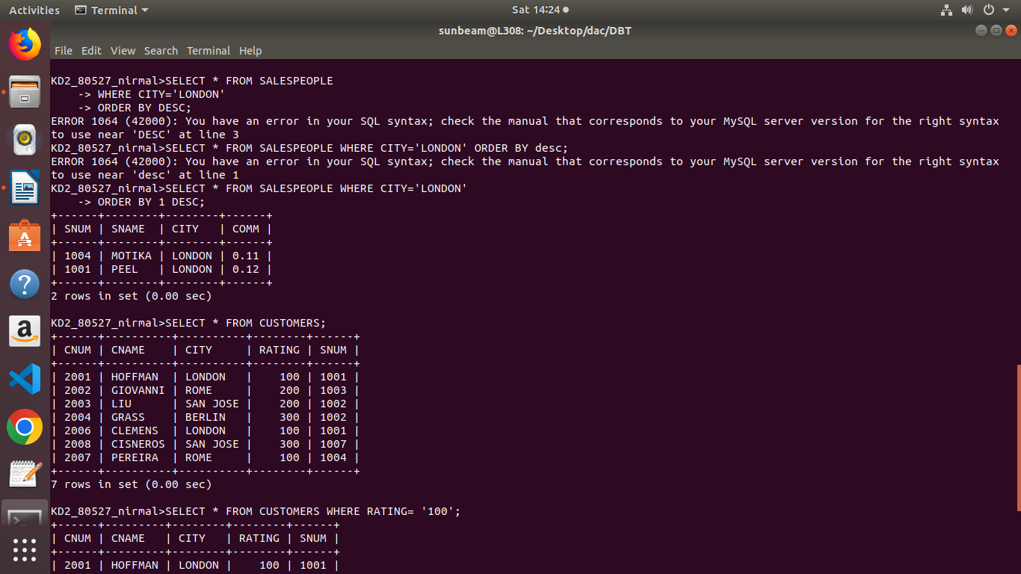

Que2) Write a query that produces the names and cities of all
customers with the same rating as Hoffman.

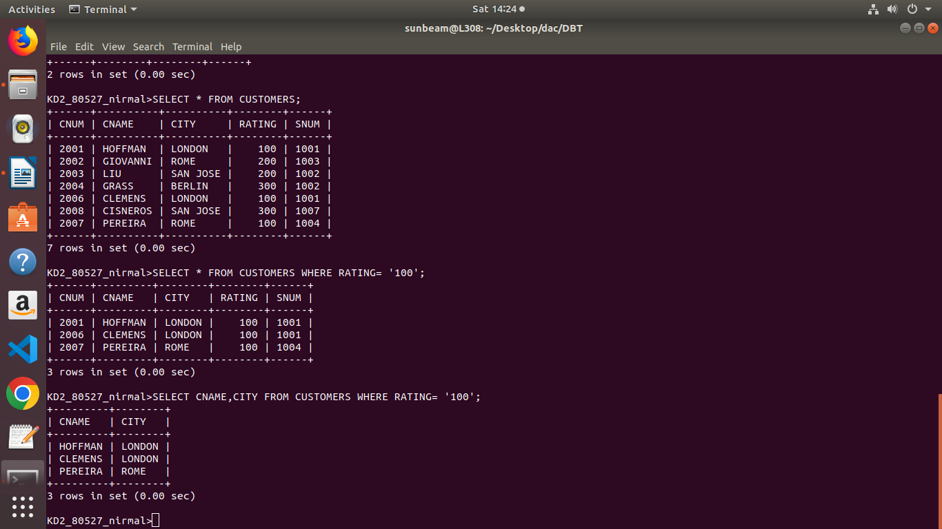
Ans)

