Assignment – 12

Que1) Write a query that selects all customers whose ratings are
equal to or greater than ANY of serres.

Ans)
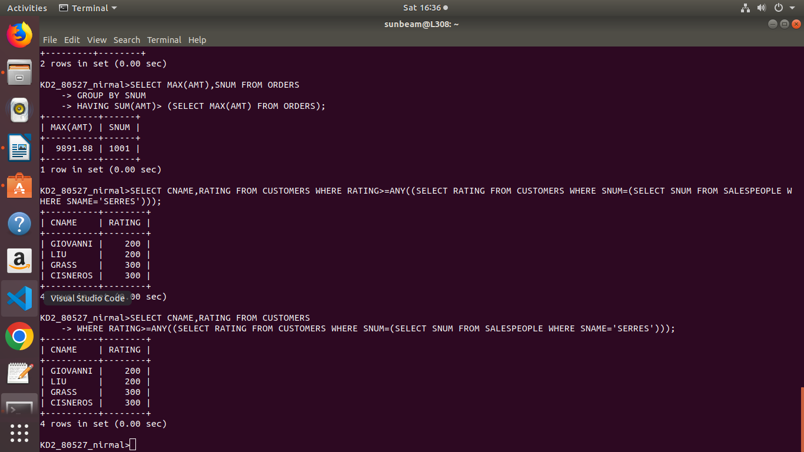

Que2) Write a query using ANY or ALL that will find all
salespeople who have no customers located in their city.
Ans)
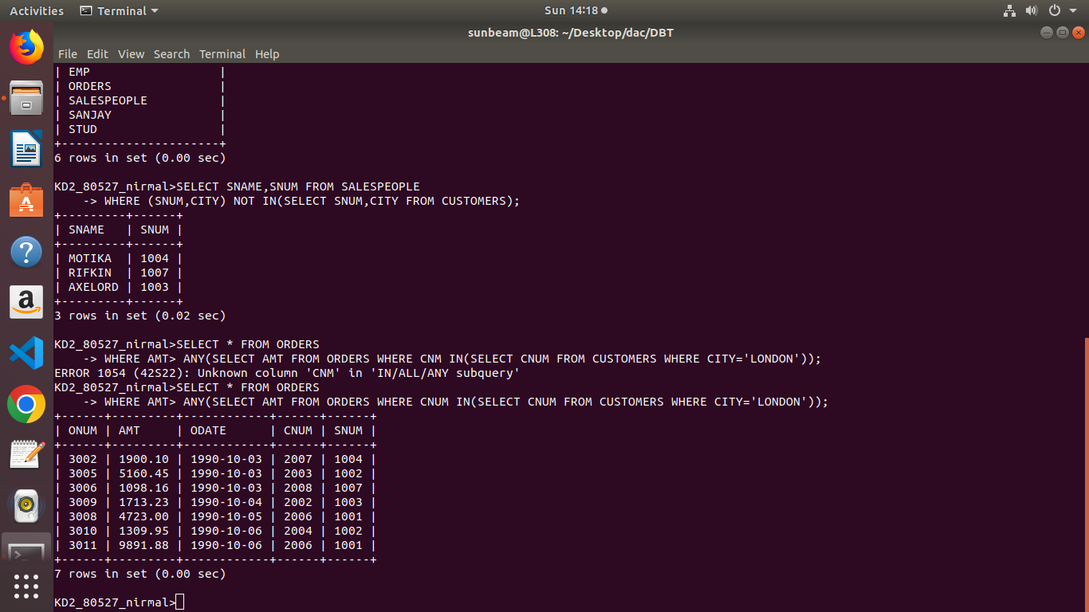

Que3) Write a query that selects all orders for amounts greater
than any for the customers in London.

Ans)
Que4) Write above query using MIN or MAX.

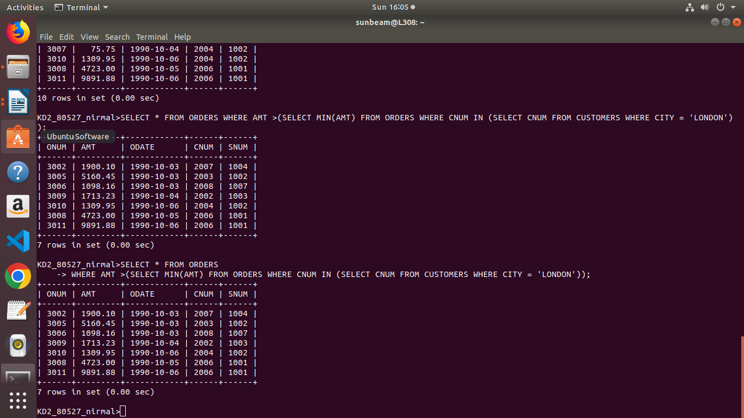
Ans)

