Assignment – 15

Que1) Assume there is a table called Multicust, with all of the
same column definitions as Salespeople.
Write a command that inserts all the salespeople with more
than one customer into this table.

Ans)
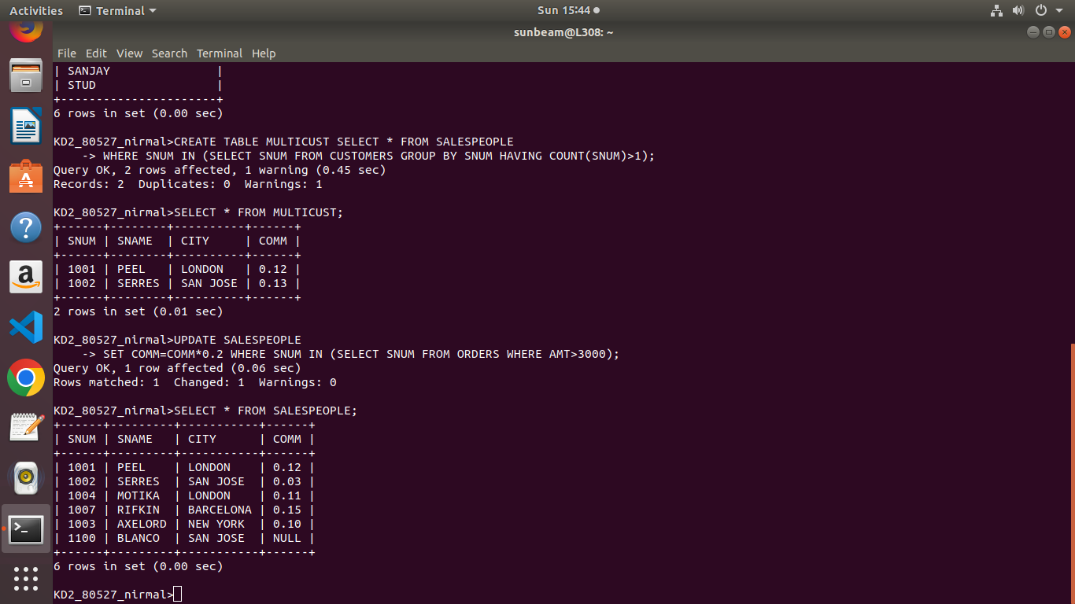

Que2) Write a command that delets all customers with no current
orders.

Ans)
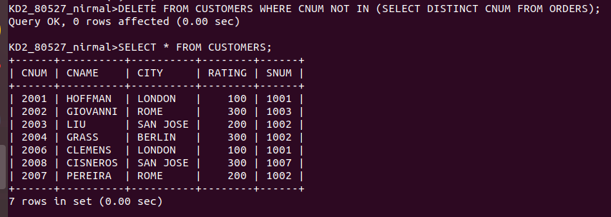

Que3) Write a command that increases by twenty percent th commisions of all salespeople with total orders above rs.3000.
Ans)

