Assignment – 14

Que1) Write a command that puts the following values, in their
given order into the salespeople table :
city – San jose, name – Blacno, comm – null , cnum -1000.

Ans)
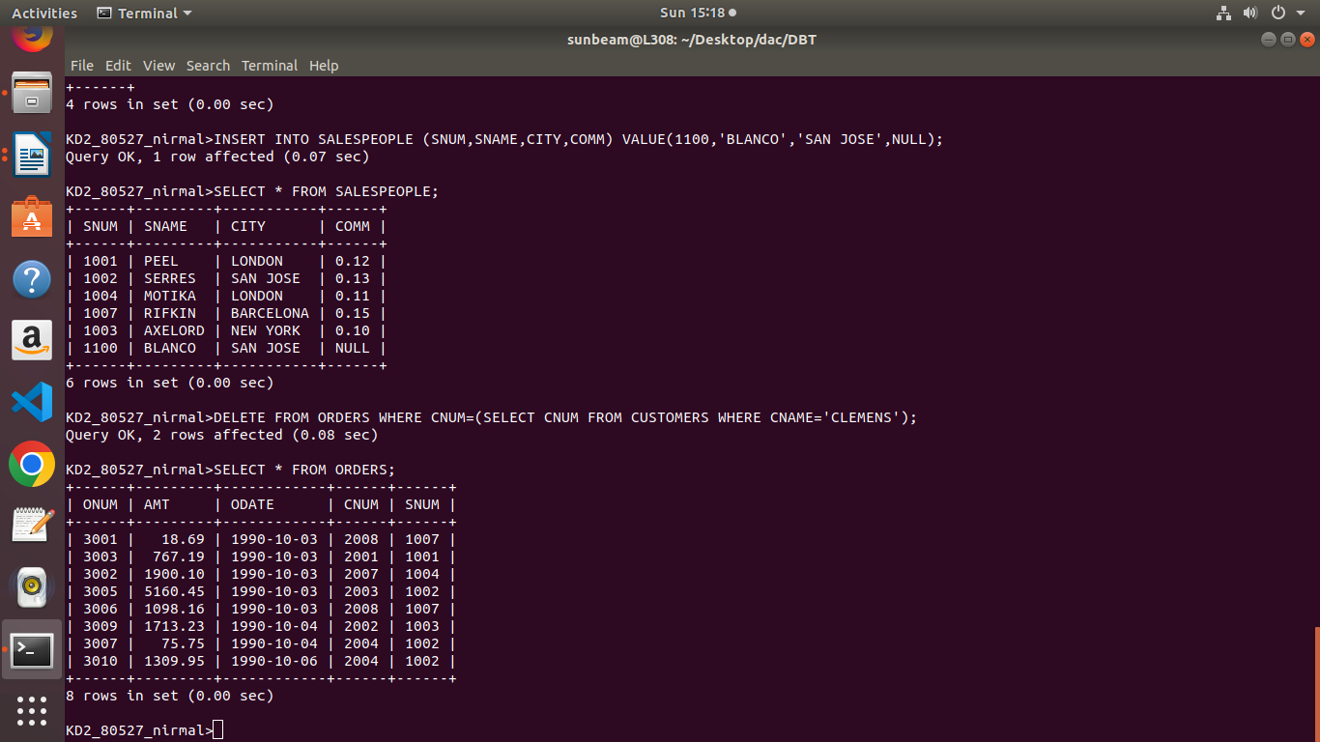

Que2) Write a command that removes all orders from customer
Clemens from the Orders table.

Ans)
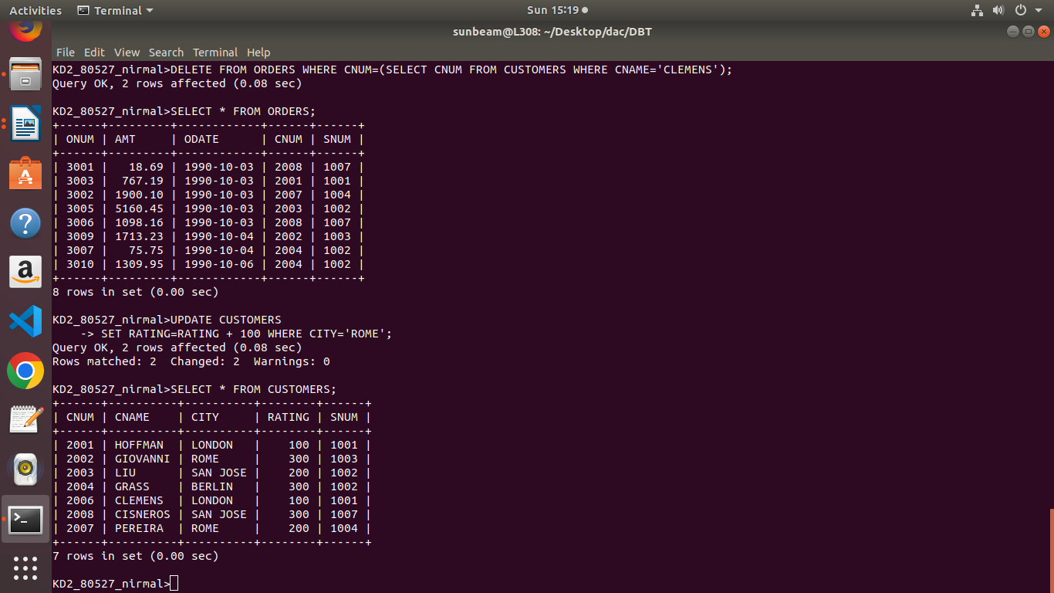

Que3) Write a command that increases the rating of all customers
in Rome by 100.

Ans)

Que4) Salesperson Serres has left the company. Assign her
customer to Motika.

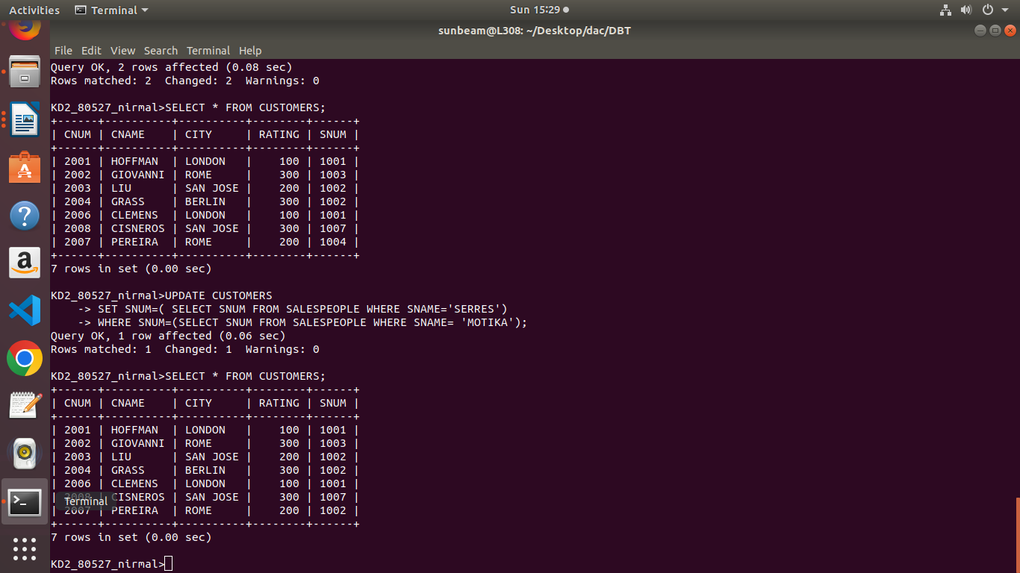
Ans)

