SQL ASSINGMENT 5
Ques 1) Write a query that will give you all orders for more than Rs. 1,000.

Sol –
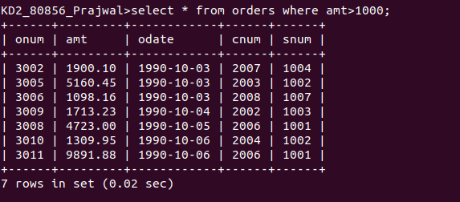

Ques 2) Write a query that will give you the names and cities of all salespeople in London with a commission above 0.10 .

Sol -
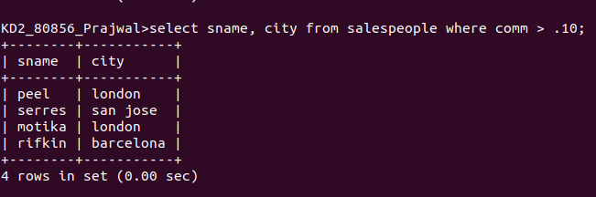

Ques 3) Write a query on the Customers table whose output will exclude all customers with a rating <= 100, unless they are located in Rome.

Sol -
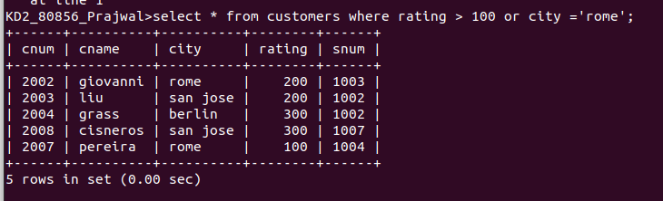
Ques 4) What will be the output from the following query?
Select * from orders
where(amt < 1000 or
not ( odate = ‘1990-10-03’ and cnum > 2003 ));
Sol – The output will be rows where amt is less than 1000 or those rows with date other than 1990-10-03.

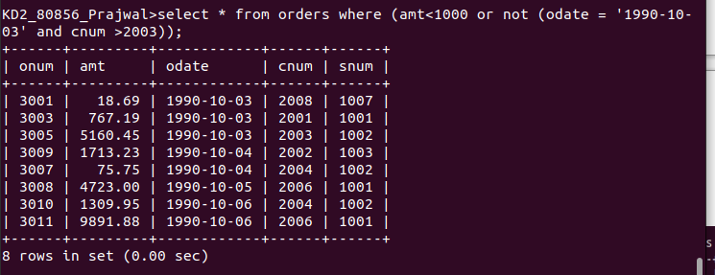

Ques 5) What will be the output of the following query?
Select * from orders
where not ((odate = ‘1990-10-03’ or snum
> 1006) and amt >= 1500);

Sol -

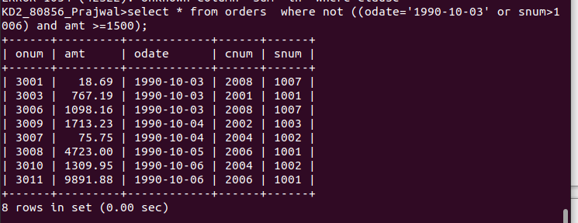

Ques 6) What is a simpler way to write this query?
Select snum, sname, city, comm from salespeoples
where (comm > .12 or comm < .14);
Sol – select * from salespeople;

