SQL ASSINGMENT 11
1)Write a query that uses a subquery to obtain all oerders for the customer named Cisneros. Assume you do not know his customer number(cnum).
Sol --
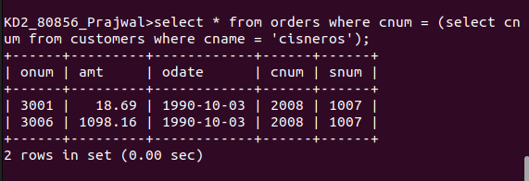

2)Write a query that produces the names and rating of all customers who have above average orders.
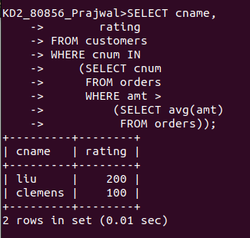
Sol --

3)Write a query that selects the total amount in orders for each salesperson for whom this total is greater than the amount of the largest order in the table.
Sol --
