SQL ASSINGMENT 14
1)Write a command that puts the following values, in their given order, into the salespeople table: city – San Jose, name – Blanco, comm – NULL, cnum – 1100.
Sol --

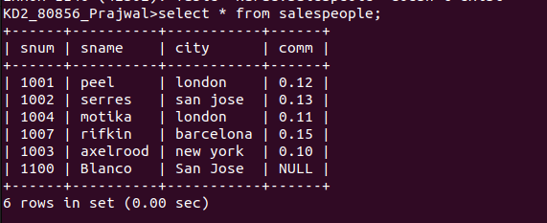

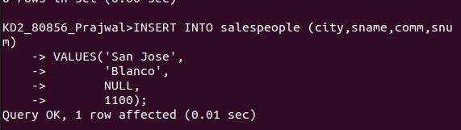
2)Write a command that removes all orders from customer clemens from the orders table.
Sol --
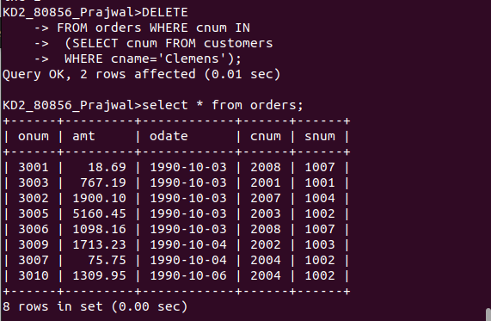
3)Write a command that increases the rating of all customers in rome by 100.
Sol --
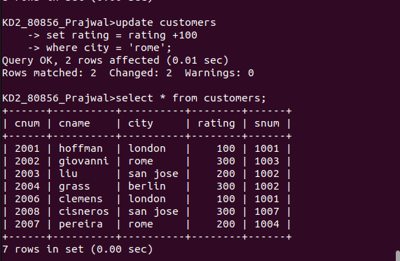

4)Salespeople Serres has left the company. Assign her customers to motika.
Sol --

