SQL ASSINGMENT 4

Ques 1) Write a select command that produces the order number, amount, and date for all rows int the orders table.

Sol -
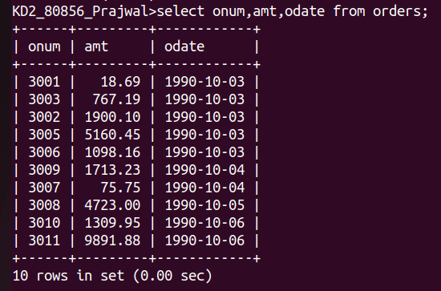
Ques 2) Write a query that produces all rows from the Customers table for which the salesperson’s number is 1001.

Sol –

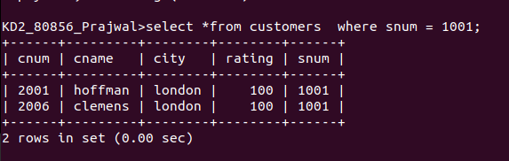

Ques 3) Write a query that displays the salespeople table with columns in the following orrder : city, sname, snum, comm.

Sol –
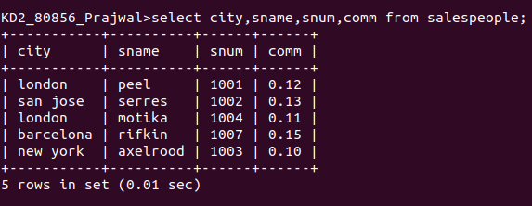

Ques 4) Write a select command that produces the rating followed by the name of each customer in San Jose.

Sol -

