***Assignment –1***

Creating sample tables and inserting values.

Create the following tables with the given structures and insert sample data as specified: -

1. *SALESPEOPLE*

Snum int(4)

Sname varchar(10)

City varchar(10)

Comm float(3,2)



1. *CUSTOMERS*

Cnum int(4)

Cname varchar(10)

City varchar(10)

Rating int(4)

Snum int(4)



1. *ORDERS*

Onum int(4)

Amt float(7,2)

Odate date

Cnum int(4)

Snum int(4)

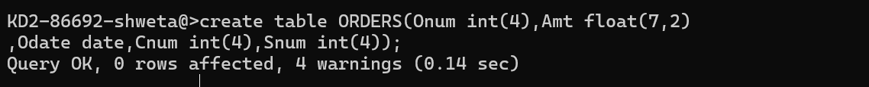

*SALES PEOPLE*

|  |  |  |  |
| --- | --- | --- | --- |
| SNUM | SNAME | CITY | COMM |
| 1001 | Peel | London | .12 |
| 1002 | Serres | San Jose | .13 |
| 1004 | Motika | London | .11 |
| 1007 | Rifkin | Barcelona | .15 |
| 1003 | Axelrod | New York | .10 |

*CUSTOMERS*

|  |  |  |  |  |
| --- | --- | --- | --- | --- |
| CNUM | CNAME | CITY | RATING | SNUM |
| 2001 | Hoffman | London | 100 | 1001 |
| 2002 | Giovanni | Rome | 200 | 1003 |
| 2003 | Liu | San Jose | 200 | 1002 |
| 2004 | Grass | Berlin | 300 | 1002 |
| 2006 | Clemens | London | 100 | 1001 |
| 2008 | Cisneros | San Jose | 300 | 1007 |
| 2007 | Pereira | Rome | 100 | 1004 |

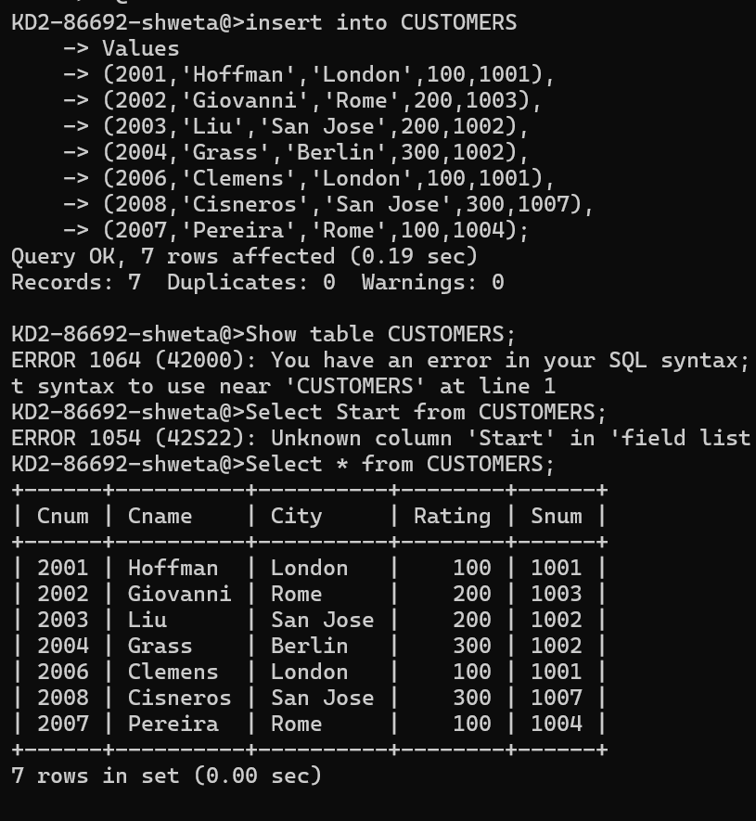

*ORDERS*

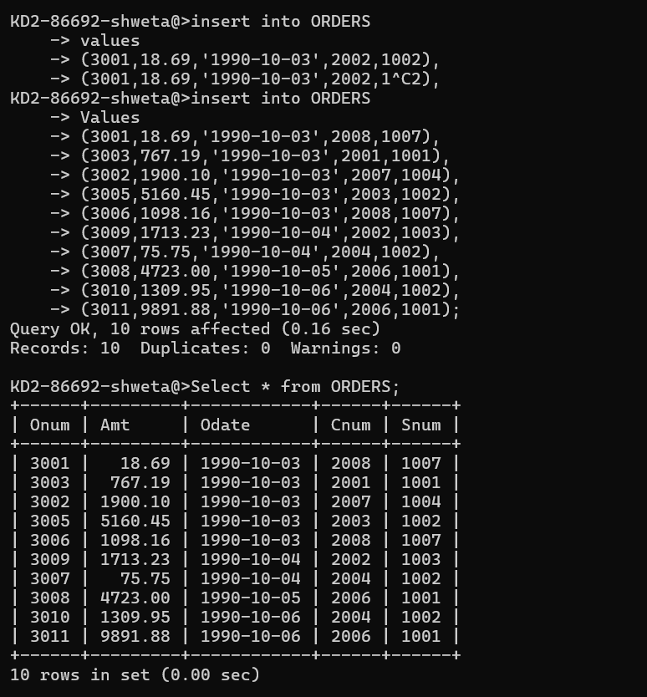

|  |  |  |  |  |
| --- | --- | --- | --- | --- |
| ONUM | AMT | ODATE | CNUM | SNUM |
| 3001 | 18.69 | 03-OCT-1990 | 2008 | 1007 |
| 3003 | 767.19 | 03- OCT -1990 | 2001 | 1001 |
| 3002 | 1900.10 | 03- OCT -1990 | 2007 | 1004 |
| 3005 | 5160.45 | 03- OCT -1990 | 2003 | 1002 |
| 3006 | 1098.16 | 03- OCT -1990 | 2008 | 1007 |
| 3009 | 1713.23 | 04- OCT -1990 | 2002 | 1003 |
| 3007 | 75.75 | 04- OCT -1990 | 2004 | 1002 |
| 3008 | 4723.00 | 05- OCT -1990 | 2006 | 1001 |
| 3010 | 1309.95 | 06- OCT -1990 | 2004 | 1002 |
| 3011 | 9891.88 | 06- OCT -1990 | 2006 | 1001 |