***Assignment – 11* Subqueries.**

1. Write a query that uses a subquery to obtain all orders for the customer named Cisneros. Assume you do not know his customer number (cnum).

select \* from orders

where cnum=

(select cnum from customers

where cname='Cisneros');

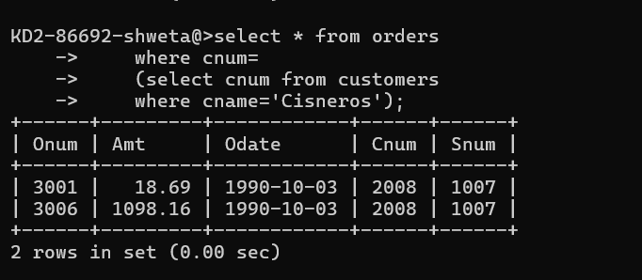

1. Write a query that produces the names and ratings of all customers who have above-average orders.

Select Cname, RAting from customers

where rating >(select avg(rating) from customers);

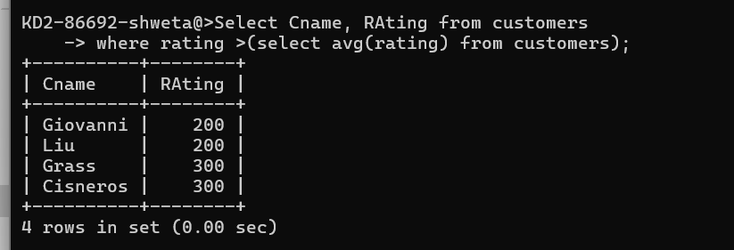

1. Write a query that selects the total amount in orders for each salesperson for whom this total is greater than the amount of the largest order in the table.

S Select sum(amt) ADDITION,Snum from orders

group by snum

having ADDITION>(select max(amt) from orders);

