***Assignment – 12***

**Using the operators IN, ANY, and ALL.**

1. Write a query that selects all customers whose ratings are equal to or greater than ANY of Serres’.

SELECT Cname, Rating

FROM Customers

WHERE Rating >= ANY ( SELECT Rating FROM Customers

WHERE Snum = (SELECT Snum FROM Salespeople

WHERE Sname = 'Serres'

)

);

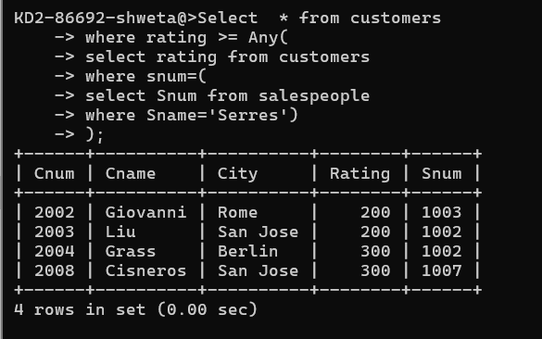

Select * from customers

where rating >= any(select rating from customers where Snum=1002 );

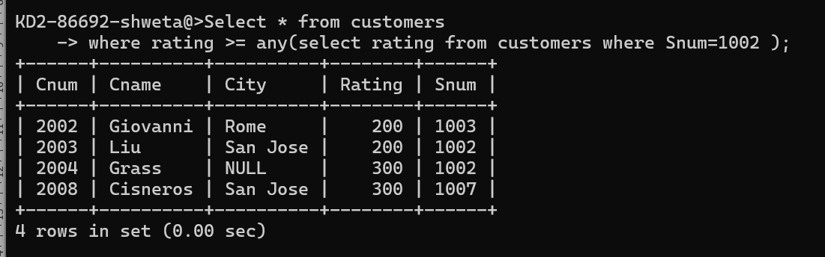

1. Write a query using ANY or ALL that will find all salespeople who have no customers located in their city.

select * from salespeople

where city != all(Select city from customers);

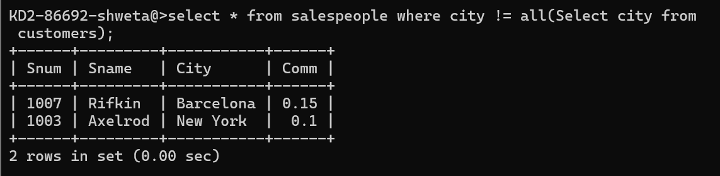

1. **Write a query that selects all orders for amounts greater than any for the customers in London.**

select * from orders

where amt> any(

select amt From orders

where Cnum in(Select Cnum From customers

where City='London'));

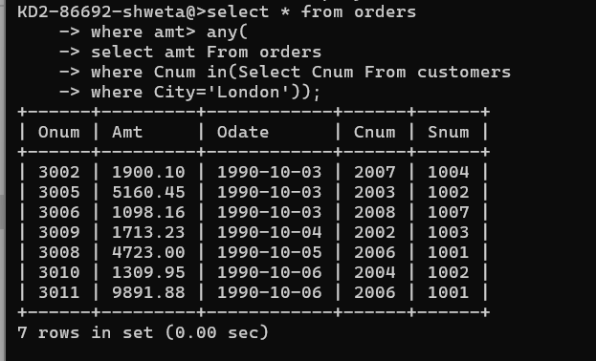

Select * from orders

where amt > any(Select Snum from customers where city='London');

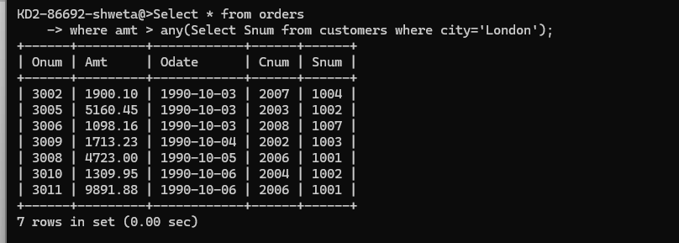

1. Write the above query using MIN or MAX.

select * from orders

-> where Amt >(

-> Select Min(Amt) from Orders

-> where Cnum In (

-> Select Cnum From Customers

-> where City= 'London'));

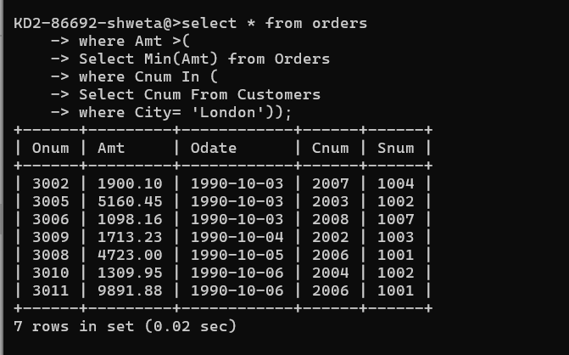

select * from orders

where amt>(select min(Snum) from customers where city = ‘london’);

