***Assignment – 13***

**Using the UNION clause.**

1. Create a union of two queries that shows the names, cities, and ratings of all customers. Those with rating of 200 or greater will also have the words “High Rating”, while the others will have the words “Low Rating”.

select Cname,city,concat('rating is : ',rating,'. High Rating')

from customers

where rating >=200

union

select Cname,city,concat('rating is : ',rating,'. Low Rating')

from customers

where rating < 200;

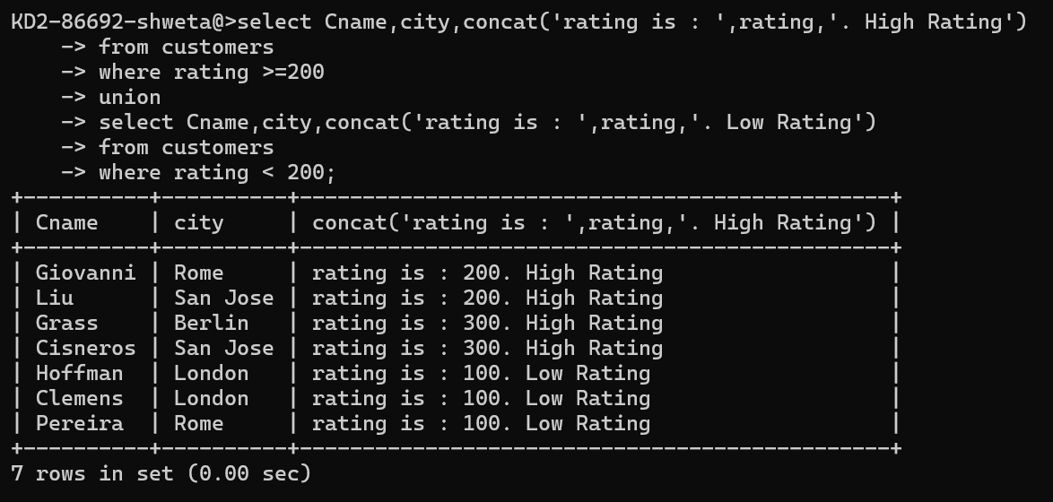

1. Write a command that produces the name and number of each salesperson and each customer with more than one current order. Put the results in alphabetical order.

select salespeople.snum,sname

from orders,salespeople

where salespeople.snum=orders.snum

group by snum,sname having

count(onum)>=2

union

select customers.cnum,cname

from orders,customers where orders.cnum=customers.cnum

g group by cnum,cname

having count(onum)>=2

o order by 2;

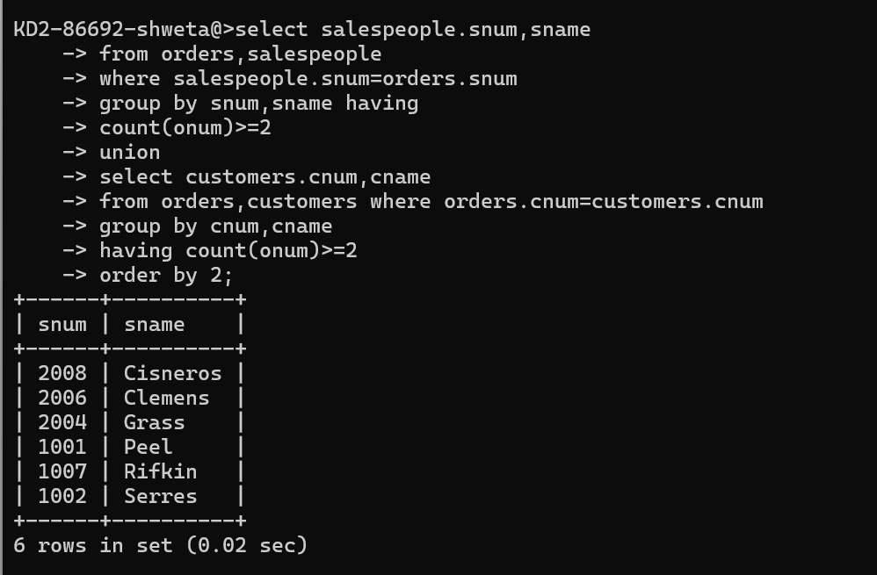

1. Form a union of three queries. Have the first select the snums of all salespeople in San Jose; the second, the cnums of all customers in San Jose; and the third the onums of all orders on October 3. Retain duplicates between the last two queries but eliminate any redundancies between either of them and the first.

(Note: in the sample tables as given, there would be no such redundancy. This is besides the point.)

Se select snum from salespeople

where city = 'San Jose'

union

select cnum from customers

where city= 'San Jose'

union

select Onum from orders

where odate='1990-10-03';

