***Assignment – 14***

**Entering, Deleting, and Changing Field Values.**

1. Write a command that puts the following values, in their given order, into the salespeople table: city – San Jose, name – Blanco, comm – NULL, cnum – 1100.

insert into salespeople(city,Sname,comm,Snum)

values('San Jose','Blanco',null,1100);

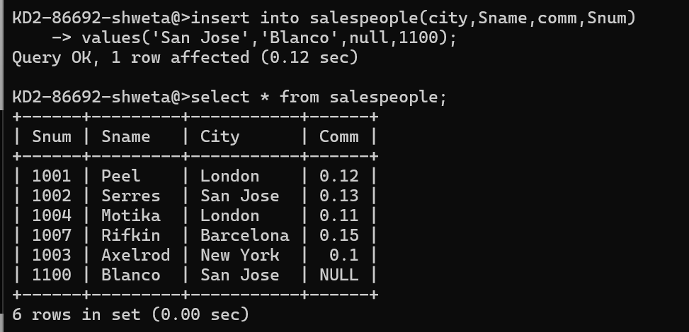

1. Write a command that removes all orders from customer Clemens from the Orders table.

delete from orders

where cnum = (select cnum from customers where cname='Clemens');

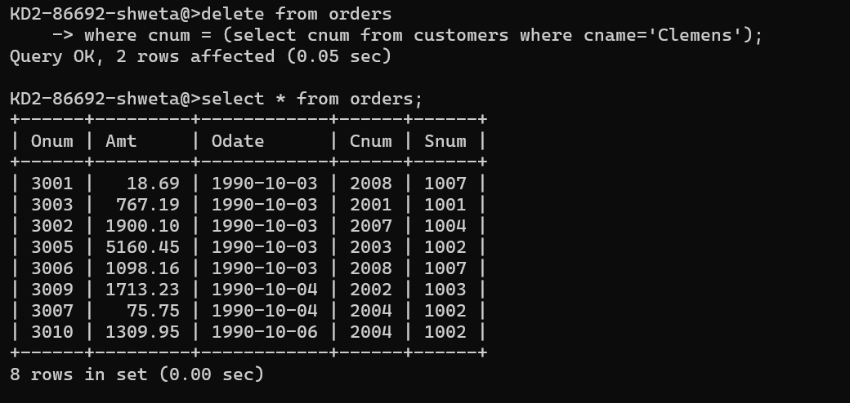

1. Write a command that increases the rating of all customers in Rome by 100.

>update customers

-> set rating= Rating +10 where city='Rome';

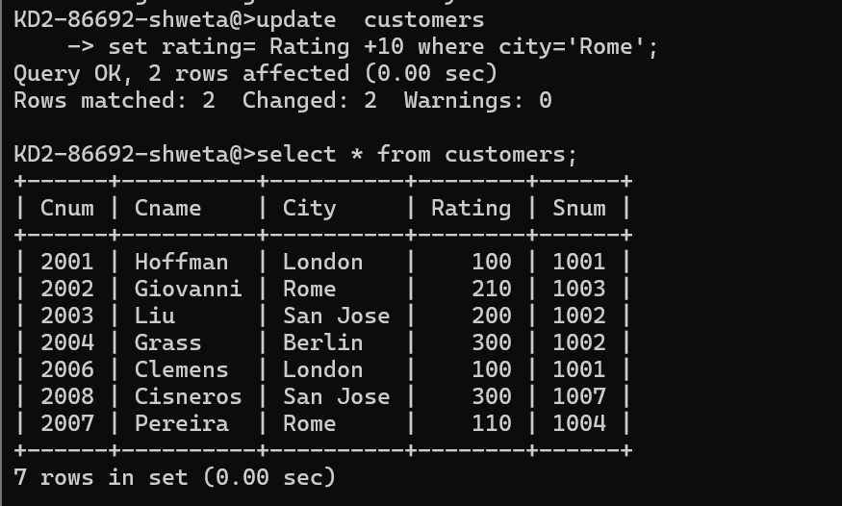

1. Salesperson Serres has left the company. Assign her customers to Motika.

*Sameer Dehadrai* Page: 1