***Assignment – 15***

**Using Subqueries with DML Commands.**

1. Assume there is a table called Multicust, with all of the same column definitions as Salespeople. Write a command that inserts all salespeople with more than one customer into this table.

Insert into Multicast select * from salespeople where snum in(select snum from customers group by snum having count(snum)>1 );

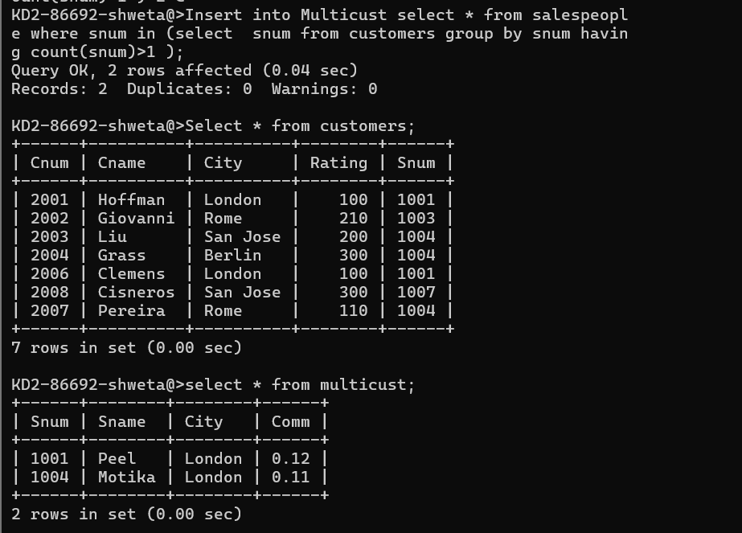

1. Write a command that deletes all customers with no current orders.

delete from customers where cnum not in (select cnum from orders);

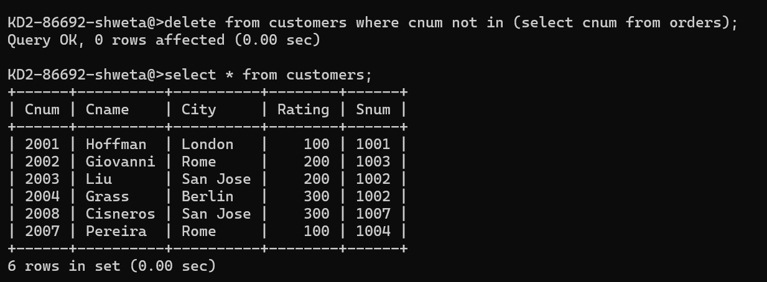

1. Write a command that increases by twenty percent the commissions of all salespeople with total orders above Rs. 3,000.

update salespeople

set comm= comm * 0.2 where snum = (select snum,sum(amt) 'Total' from orders group by snum having Total > 3000 );