***Assignment –5* Relational and Logical Operators.**

1. Write a query that will give you all orders for more than Rs. 1,000.

SELECT order FROM orders

Where Amt>1000;

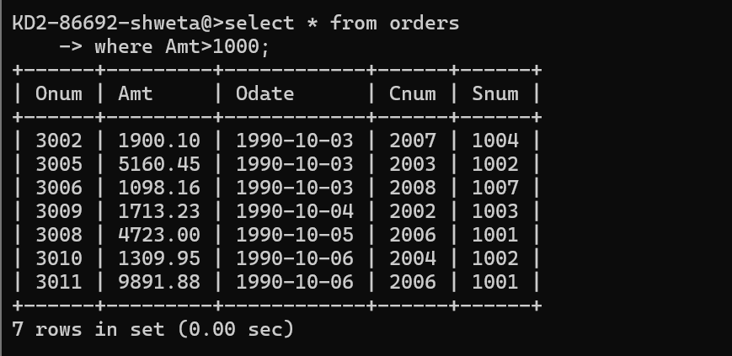

1. Write a query that will give you the names and cities of all salespeople in London with a commission above .10.

Select Sname ,City

From salespeople

Where city=’London’ ans comm>.10;

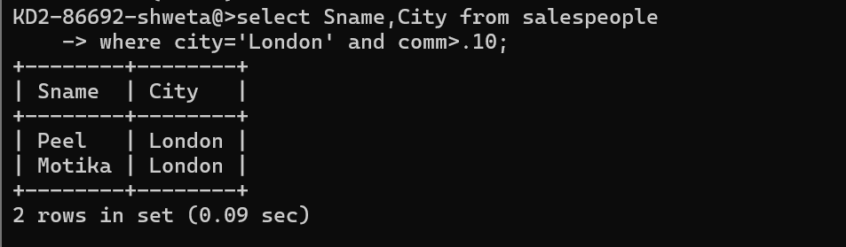

1. Write a query on the Customers table whose output will exclude all customers with a rating <= 100, unless they are located in Rome.

Select \* from customers

Where

Rating >100 or City=”Rome”;

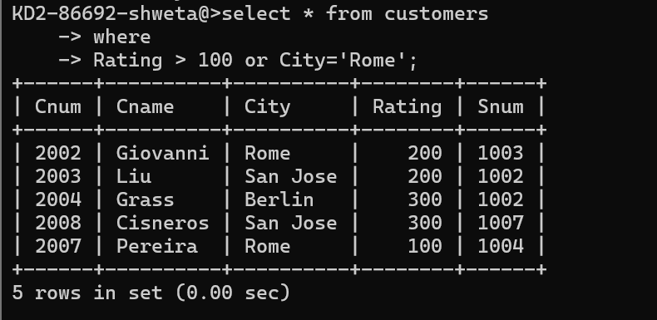

1. What will be the output from the following query?

Select \* from Orders

where (amt < 1000 OR

NOT (odate = ‘1990-10-03’

AND cnum > 2003));

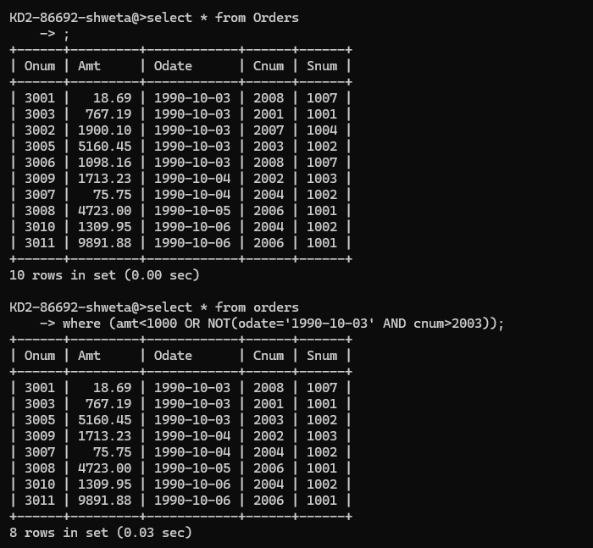

1. What will be the output of the following query?

Select \* from Orders where NOT ((odate = ‘1990-10-03’ OR snum

>1006) AND amt >= 1500);

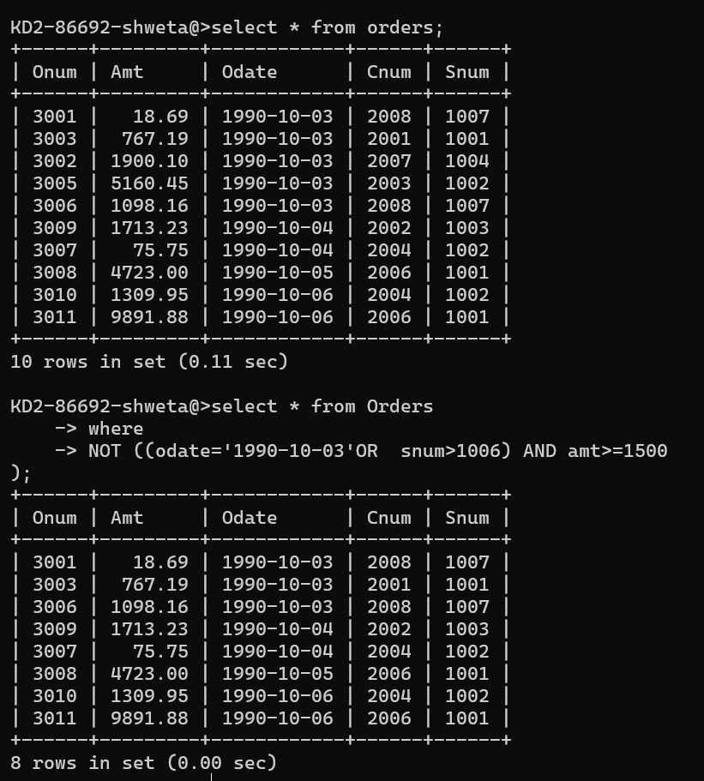

1. What is a simpler way to write this query?

Select snum, sname, city, comm From Salespeople where (comm > .12 OR comm <.14);