***Assignment –6***

**Using Special Operators in Conditions.**

1. Write two different queries that would produce all orders taken on October 3rd or 4th, 1990.

Select * from orders

Where odate=’1990-10-03’ or odate=’1990-10-04’;

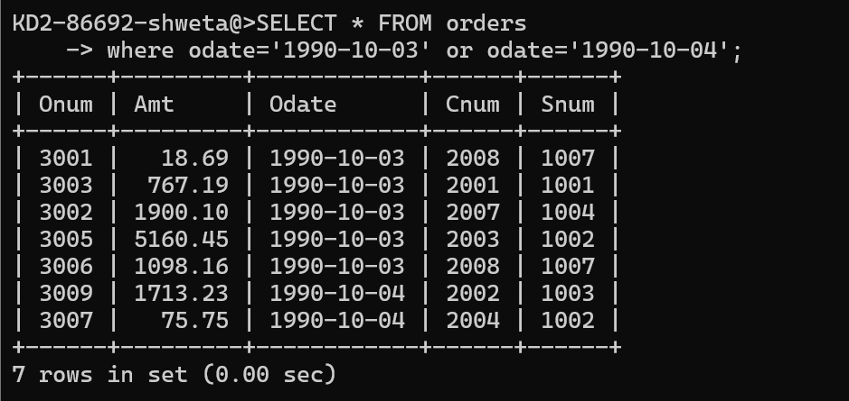

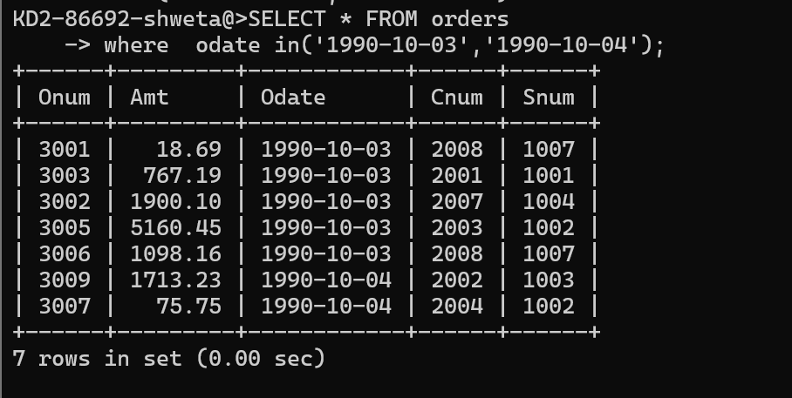

1. Write a query that selects all of the customers serviced by Peel or Motika. (Hint: the snum field relates the two tables to one another).

Select cname,sname from salespeople,customers

Where salespeople.snum=customers.snum and sname in(‘peel’,’Motika’);

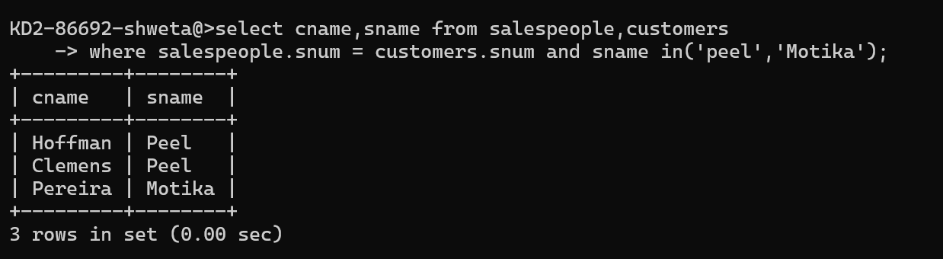

1. Write a query that will produce all the customers whose names begin with a letter from ‘A’ to ‘G’.

Select cname,cnum,rating,snum from customers

Where cname between ‘A’ and ‘H’;

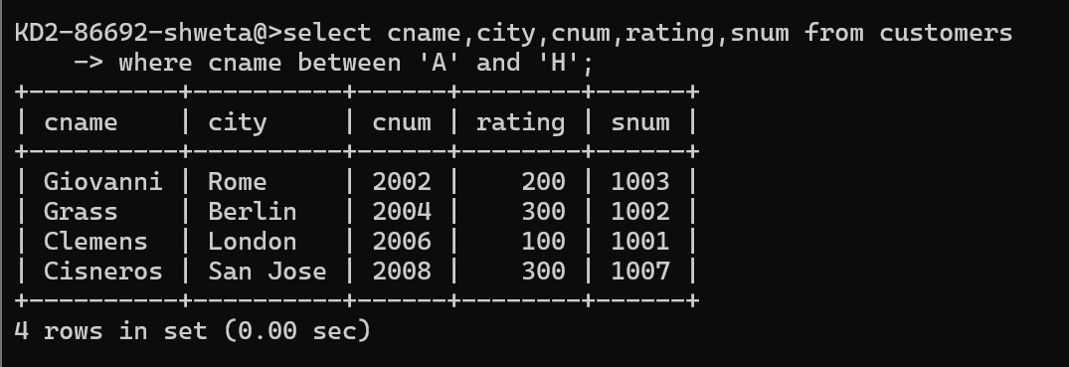

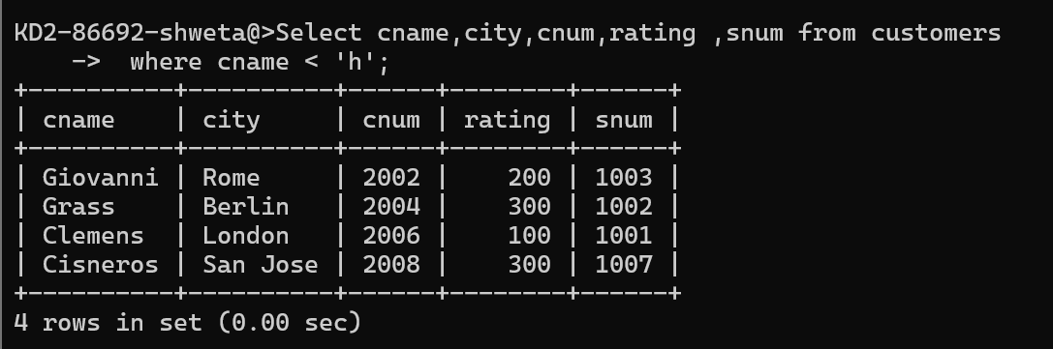

1. Write a query that selects all customers whose names begin with the letter ‘C’

Select * from customers

Where cname like ‘C%’;

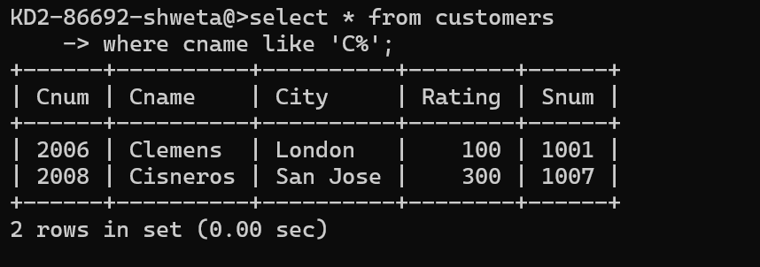

1. Write a query that selects all orders except those with zeroes or NULLs in the amt field.

Select * from orders

Where Amt !=0 and Amt is not null;

