***Assignment –8***

**Formatting Query output.**

1. **Assume each salesperson has a 12% commission. Write a query on the orders table that will produce the order number, the salesperson number, and the amount of the salesperson’s commission for that order.**

Select Onum , Snum,Amt, Amt*0.12 'Commission'

from orders;

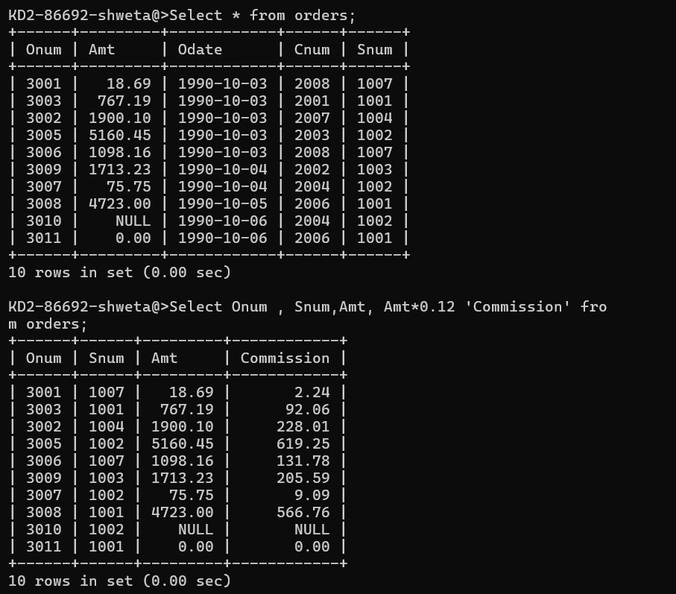

1. **Write a query on the Customers table that will find the highest rating in each city. Put the output in this form:**

For the city (city), the highest rating is : (rating).

select concat('For the City : ',city,". The Highest rating is : ",max(rating))

as "Highest Rating In City"

from customers

group by city;

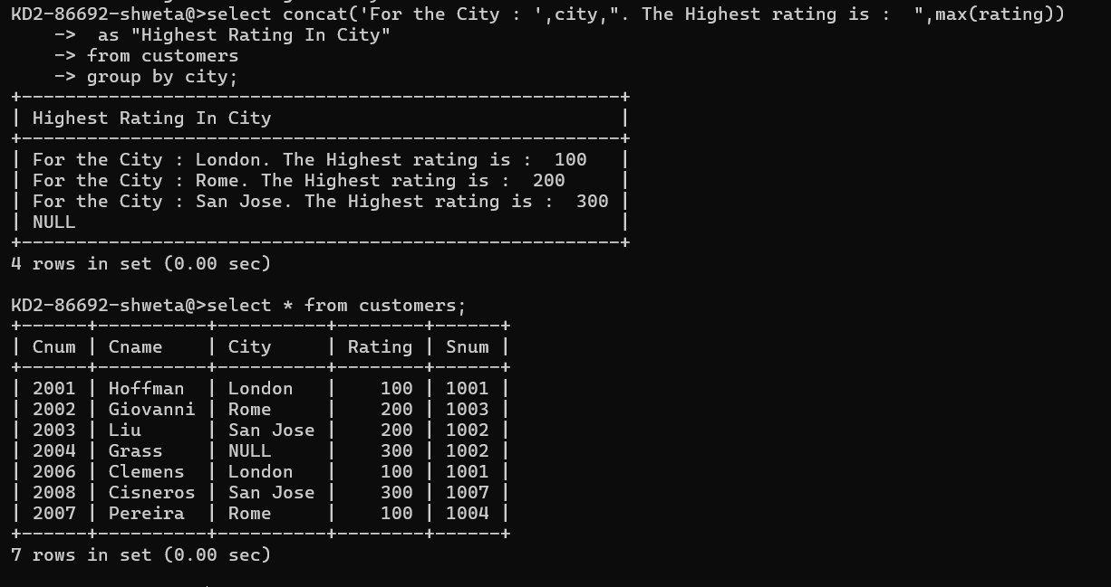

1. **Write a query that lists customers in descending order of rating. Output the rating field first, followed by the customer’s name and number.**

Select Rating,Cname,snum from customers

order by rating desc;

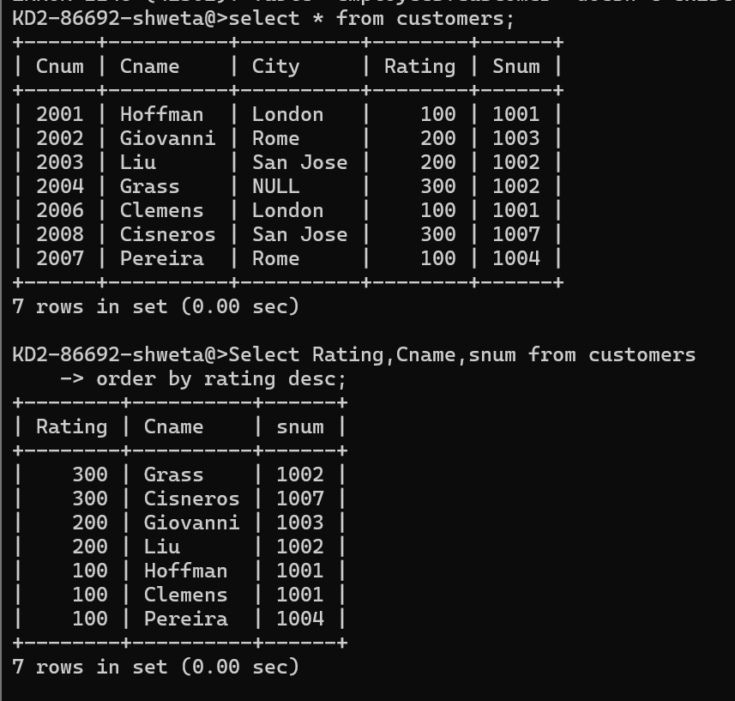

1. **Write a query that totals the orders for each day and places the results in descending order.**

Select Odate,count(Odate) as date_count from orders

group by odate

order by date_count desc;

