***Assignment – 9* Querying Multiple Tables at Once.**

1. Write a query that lists each order number followed by the name of the customer who made the order.

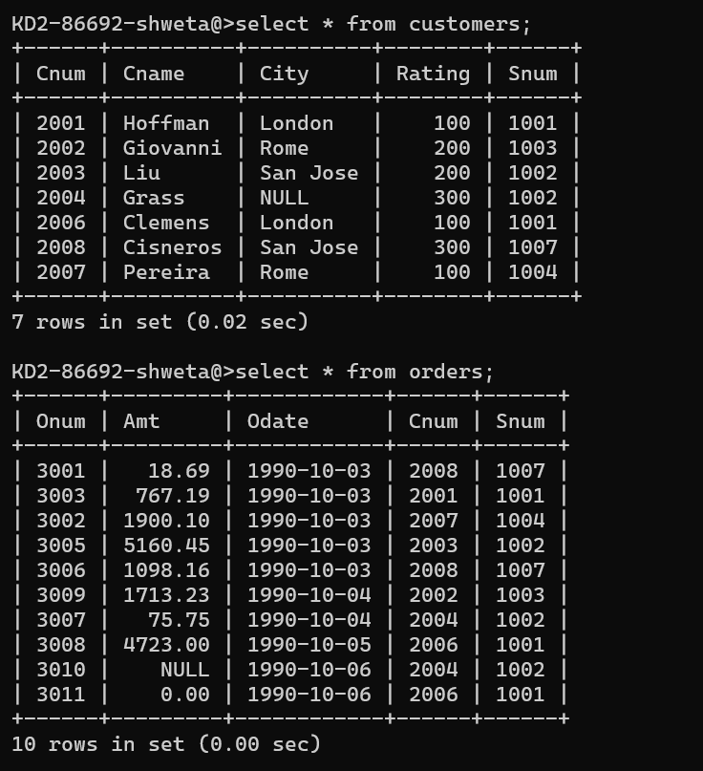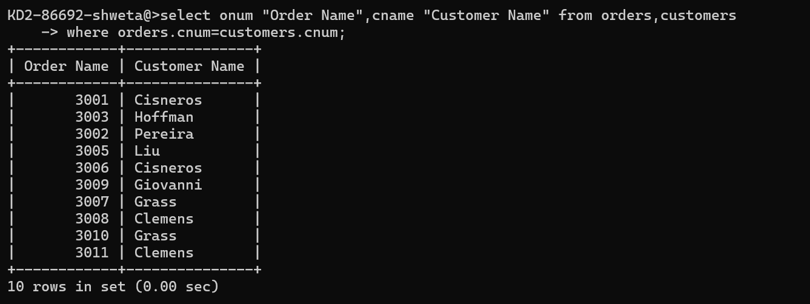

1. Write a query that gives the names of both the salesperson and the customer for each order along with the order number.

select Sname "Salesperson",Cname "Customer Name",Onum "Order

Number" ,Amt,odate

from salespeople,Customers,orders

where

salespeople.snum=customers.snum

and

orders.snum=salespeople.snum;

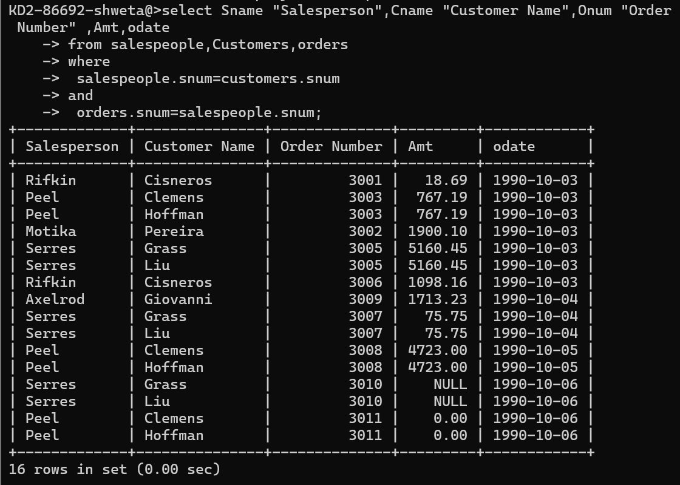

1. Write a query that produces all customers serviced by salespeople with a commission above 12%. Output the customer’s name, the salesperson’s name, and the salesperson’s rate of commission.

Select Cname,Sname,Comm

from salespeople,Customers

where

salespeople.snum=Customers.snum

and

comm > 0.12;

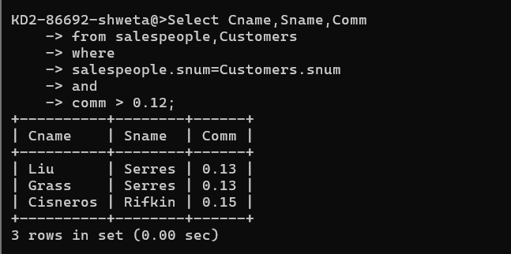

1. Write a query that calculates the amount of the salesperson’s commission on each order by a customer with a rating above 100.

* Select Sname, Amt, Amt \* 0.12 "Commission",Rating

From salespeople,orders,customers

where

salespeople.snum=orders.snum

and

salespeople.snum=customers.snum

and

Rating >100;

