ASSIGNMENT-5

Create file named grade.txt and write following contents in it.

---------------------

John Smith: A

Mary Johnson: B

Alex Rodriguez: C

Emily Wong: A

David Lee: B

James Johnson: A

Edwin Albert: B

---------------------

1. Count the number of students.

2. List the students having grade A.

3. List the students not having grade B.

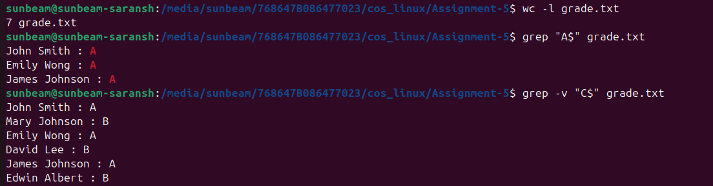

4. Print the count of students not having grade C.

5. List the student/students whose name starts with E & having grade B.

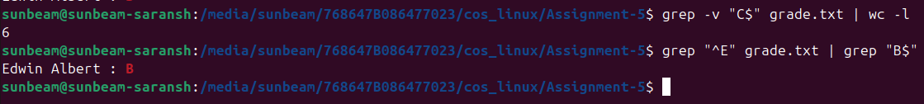

6. Show only Students first name & Last Name.

7. Show only grades.

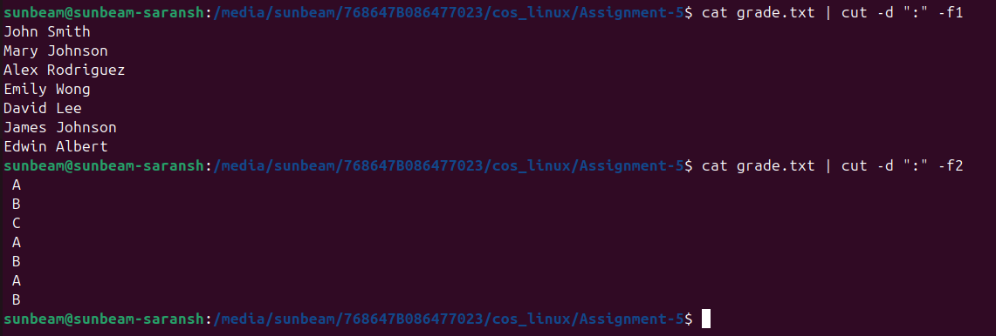8. Show only first name & grades.

