Create file named grade.txt and write following contents in it. ( grep , cut )
---------------------
John Smith: A
Mary Johnson: B
Alex Rodriguez: C
Emily Wong: A
David Lee: B
James Johnson: A
Edwin Albert: B
---------------------
And compose commands to perform following operations
1. Count the number of students. ( wc )
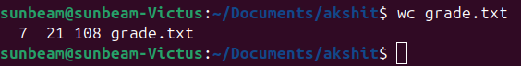
2. List the students having grade A. ( grep )
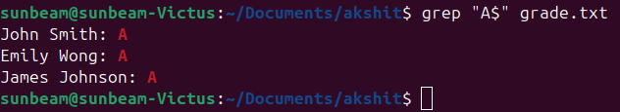
3. List the students not having grade B. ( grep )
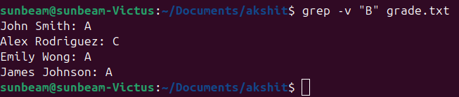
4. Print the count of students not having grade C. ( grep )
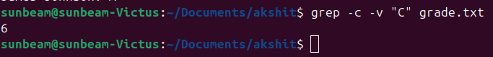
5. List the student/students whose name starts with E & having grade B. ( grep )
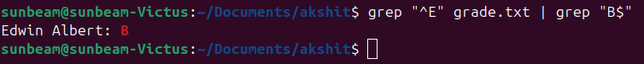
6. Show only Students first name & Last Name. ( cut )
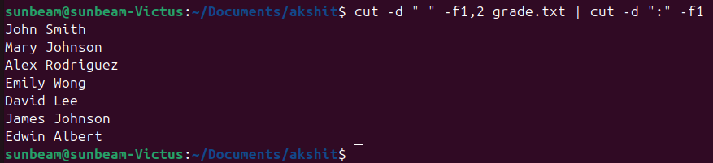
7. Show only grades. ( cut )
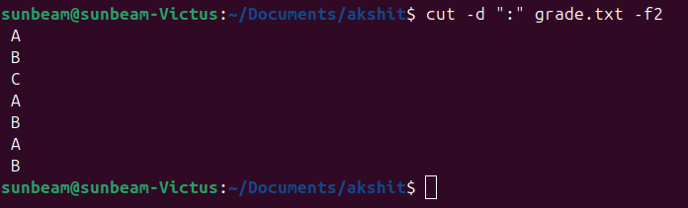
8. Show only first name & grades. ( cut )
