ASSIGNMENT-1

Create the following tables with the given structures and insert sample data as specified: -

A)

*SALESPEOPLE*

Snum int(4)

Sname varchar(10)

City varchar(10)

Comm float(3,2) 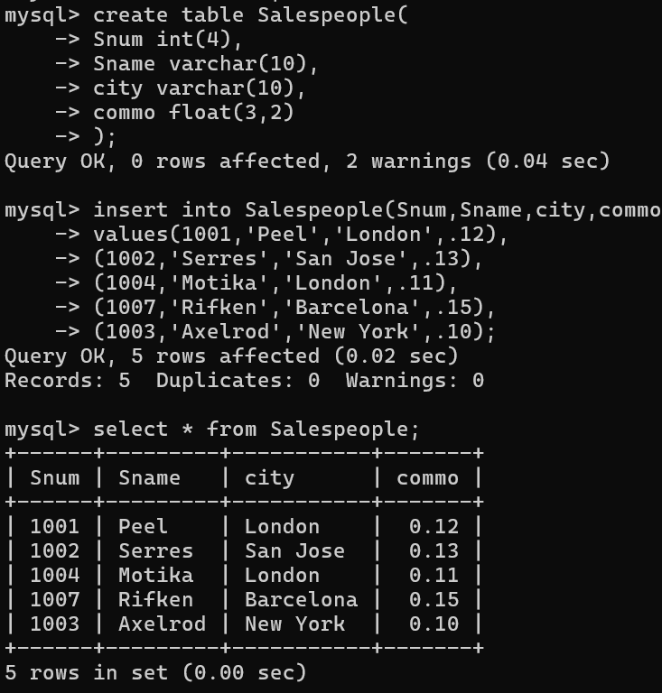

*B)*

*CUSTOMERS*

Cnum int(4)

Cname varchar(10)

City varchar(10)

Rating int(4)

Snum int(4)

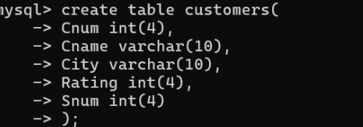

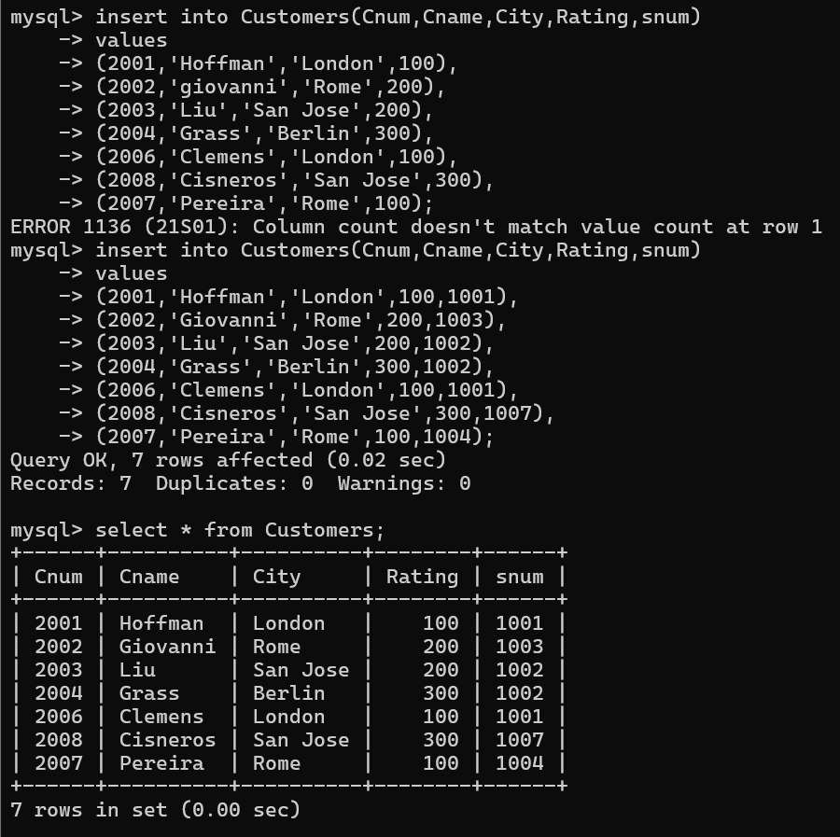

*C)*

*ORDERS*

Onum int(4)

Amt float(7,2)

Odate date

Cnum int(4)

Snum int(4)

