ASSIGNMENT-20

Q1. Which of these views are updateable (will allow DML operations)?

1. Create View Dailyorders as Select Distinct cnum, snum, onum, odate from Orders;
2. Create View Custotals as Select cname, Sum (amt) Sum_Amt from Orders, Customers where Orders.cnum=Customers.cnum Group by cname;
3. Create view Thirdorders as Select * from Dailyorders where odate=’1990-10-03’;
4. Create view Nullcities as Select snum, sname, city from Salespeople where city is NULL OR sname BETWEEN ‘A’ and ‘MZ’;

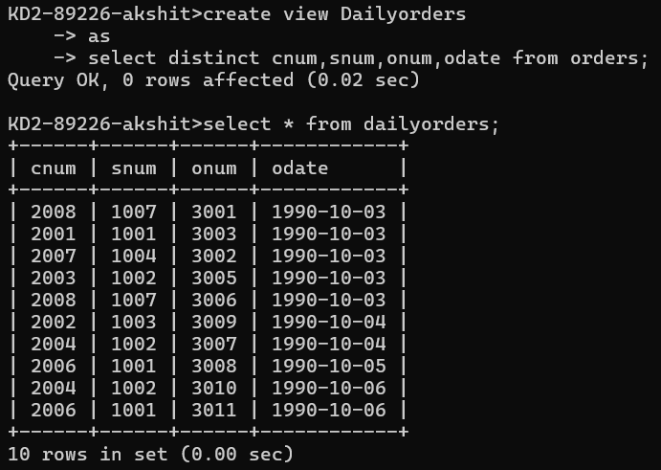

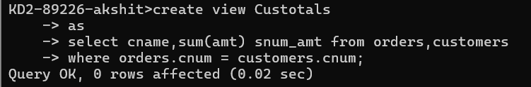

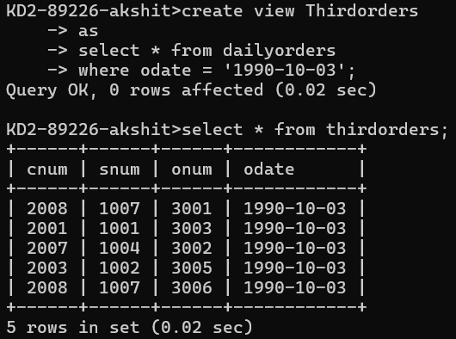

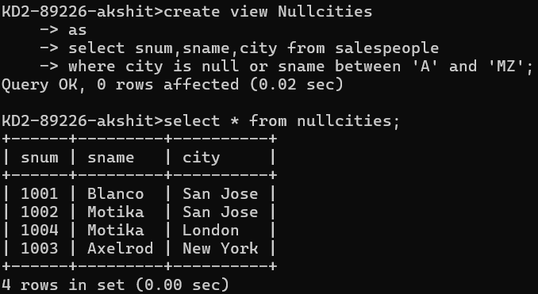

Q2. Create a view of the Salespeople table called Commissions. This view will include only the snum and comm fields. Through this view, someone could enter or change commissions, but only to values between .10 and .20.

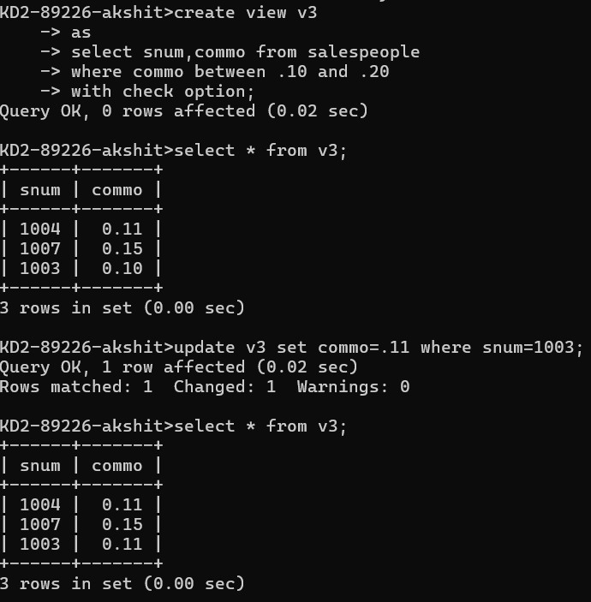

Q3. Some SQL implementations have a built-in constant representing the current date, sometimes called “CURDATE” or “SYSDATE”. The word SYSDATE can therefore be used in a SQL statement, and be replaced by the current date when the value is accessed by commands such as Select or Insert. We will use a view of the Orders table called Entryorders to insert rows into the Orders table. Create the Orders table, so that SYSDATE is automatically inserted for odate if no value is given. Then create the Entryorders view so that no values can be given.

