ASSIGNMENT-21

Q1. Give Amit the right to change the ratings of the customers.





Q2. Give Manoj the right to give other users the right to query the Orders table.

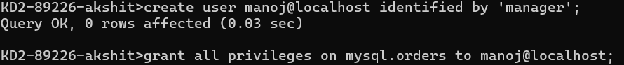

Q3. Take the INSERT privilege on Salespeople away from Ajita.



Q4. Grant Abhijeet the right to insert or update the Customers table while keeping her possible rating values in the range of 100 to 500.

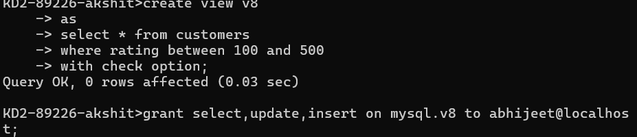

Q5. Allow Vikram to query the Customers table, but restrict his access to those customers whose rating is the lowest.

