Assignment-5

1. Write a query that will give you all orders for more than Rs. 1,000.

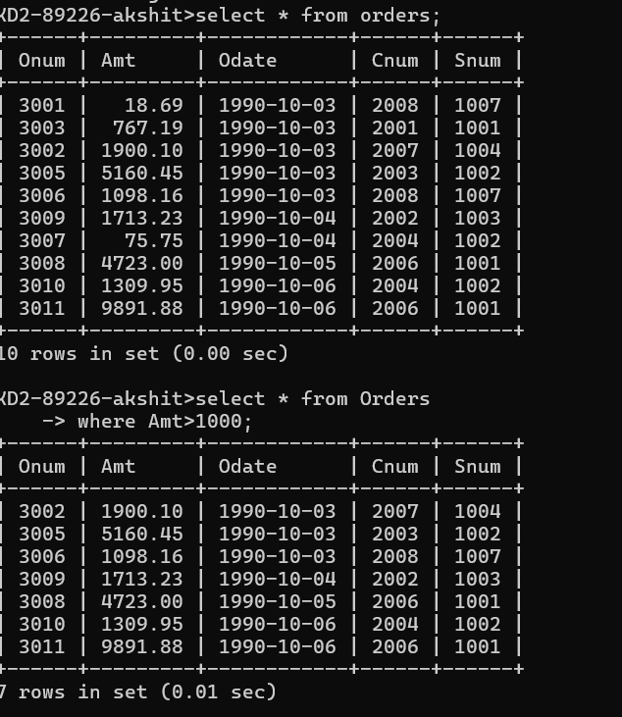

1. Write a query that will give you the names and cities of all salespeople in London with a commission above .10.

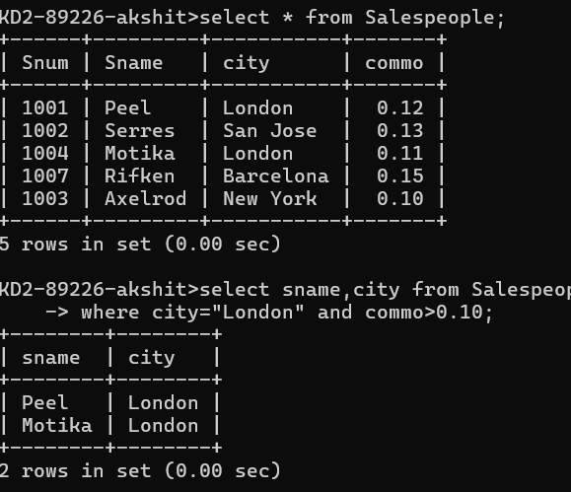

1. Write a query on the Customers table whose output will exclude all customers with a rating <= 100, unless they are located in Rome.

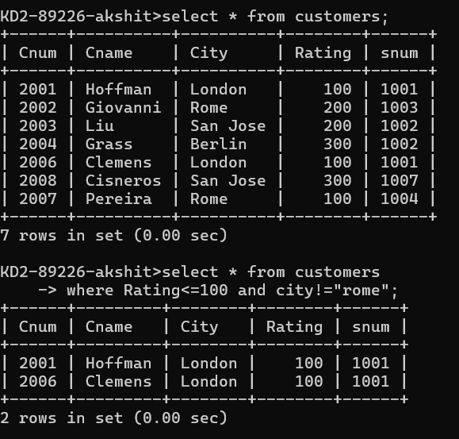

1. What will be the output from the following query?

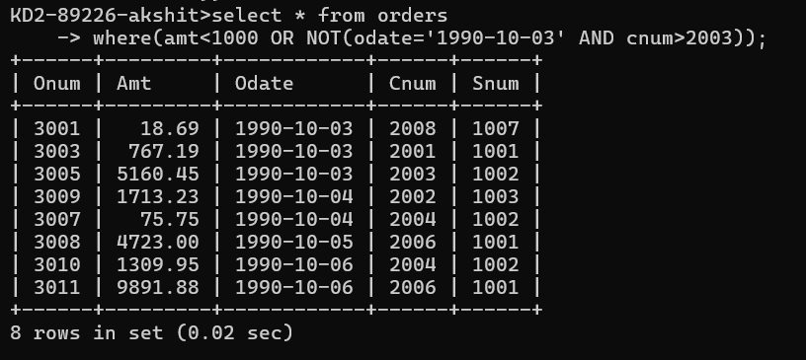

1. What will be the output of the following query?

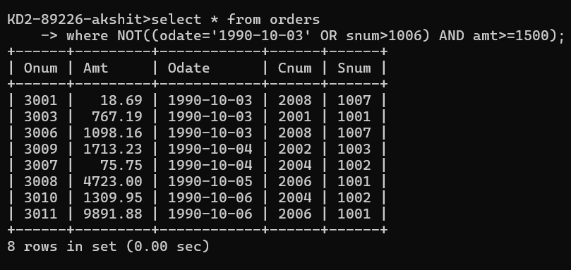

1. What is a simpler way to write this query?

