Assignment 1

Create the following tables with the given structures and insert sample data as specified: -

A) SALESPEOPLE

Snum int (4)

Sname varchar (10)

City varchar (10)

Comm float (3,2)

Query for table 1:

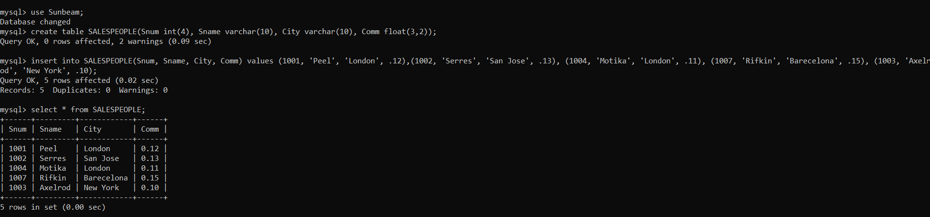

Table1:

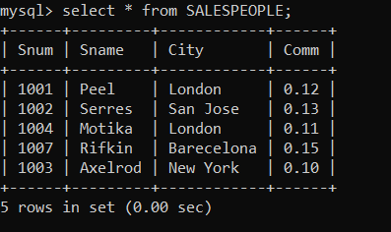

B) CUSTOMERS

Cnum int (4)

Cname varchar (10)

City varchar (10)

Rating int (4)

Snum int (4)

Query for table 2:

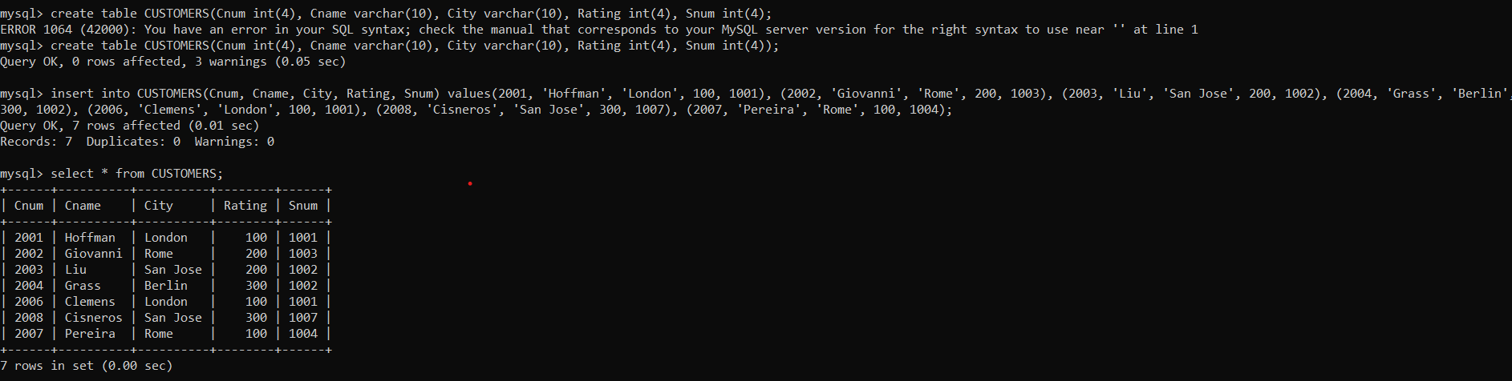

tables-2

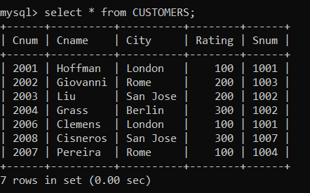

C) ORDERS

Onum int (4)

Amt float (7,2)

Odate date

Cnum int (4)

Snum int (4)

Query for table 3:

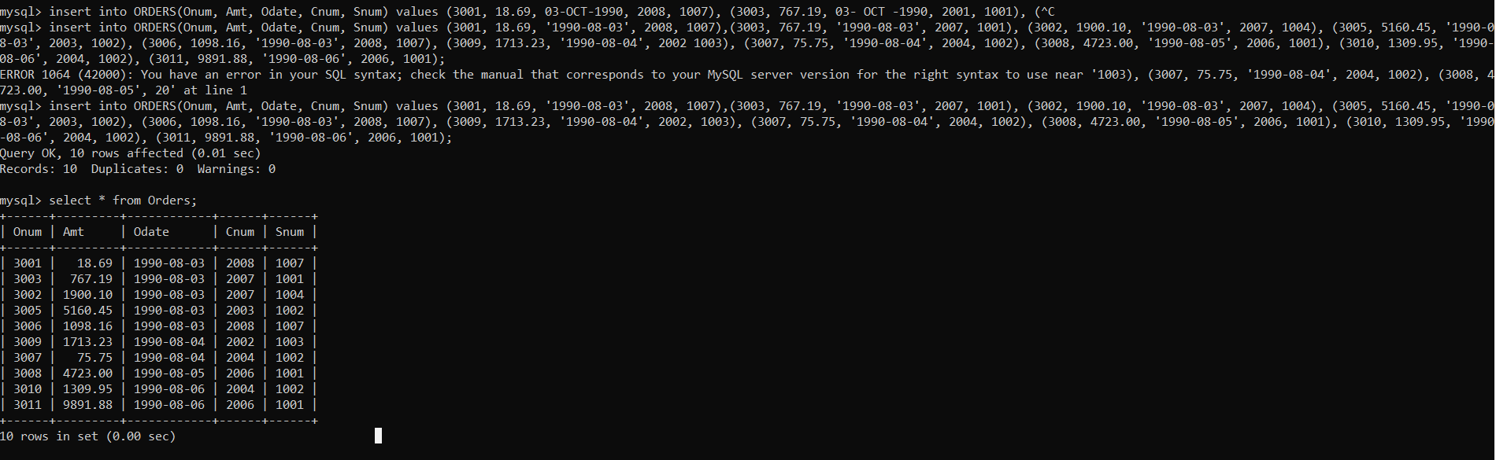

Table3-

