Assignment –6

Using Special Operators in Conditions.

1) Write two different queries that would produce all orders taken on October 3rd or

4th, 1990.

query1-

select \* from orders where odate='1990-10-03' or odate='1990-10-04';

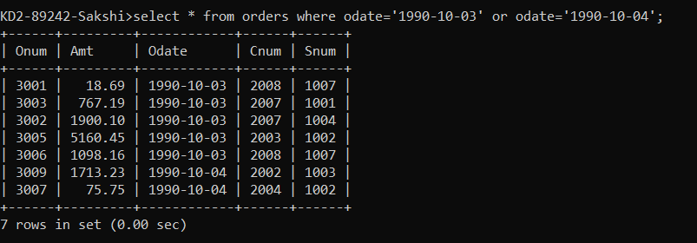

query2-

select \* from orders where odate in('1990-10-03','1990-10-04');

query3-

select \* from orders where odate between '1990-10-03' and '1990-10-04';

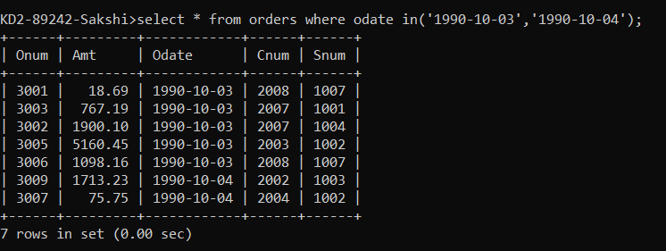

2) Write a query that selects all of the customers serviced by Peel or Motika.

(Hint: the snum field relates the two tables to one another).

select \* from customers where snum=1001 or snum=1004;

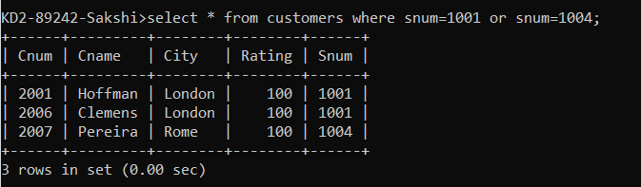

3) Write a query that will produce all the customers whose names begin with a letter

from ‘A’ to ‘G’.

select \* from customers where cname between 'A' and 'H';

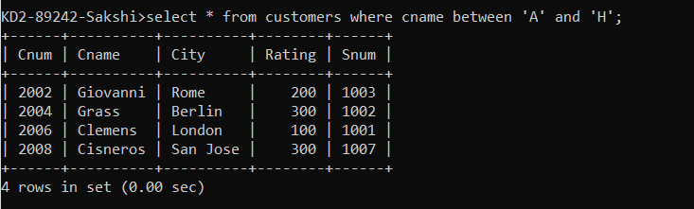

4) Write a query that selects all customers whose names begin with the letter ‘C’.

select \* from customers where cname like 'C%';

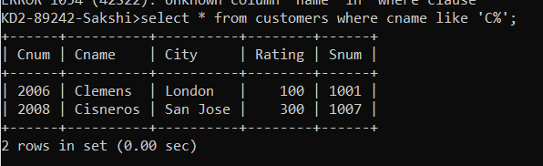

5) Write a query that selects all orders except those with zeroes or NULLs in the amt

field.

select \* from orders where Amt!= null or Amt!=0;

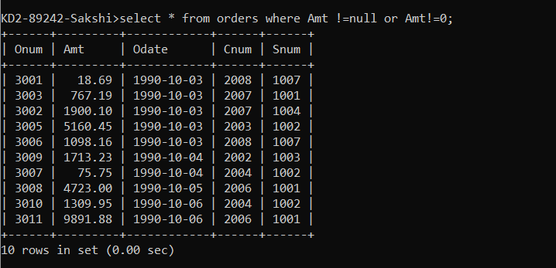

select \* from orders where Amt not in(0) or amt not in(null);

