**Assignment – 15**

**Using Subqueries with DML Commands.**

Q.1) Assume there is a table called Multicust, with all of the same column definitions as Salespeople. Write a command that inserts all salespeople with more than one customer into this table?

Ans.

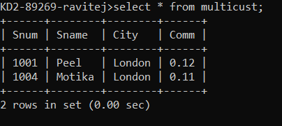

Q.2) Write a command that deletes all customers with no current orders?

Ans.

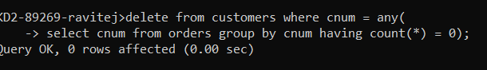

Q.3) Write a command that increases by twenty percent the commissions of all salespeople with total orders above Rs. 3,000?

Ans.

