**Assignment – 19**

**Views**

Q1. Create a view that shows all of the customers who have the highest ratings.

Ans.

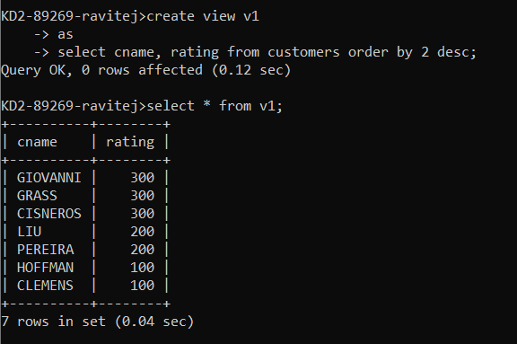

Q2. Create a view that shows the number of salespeople in each city.

Ans.

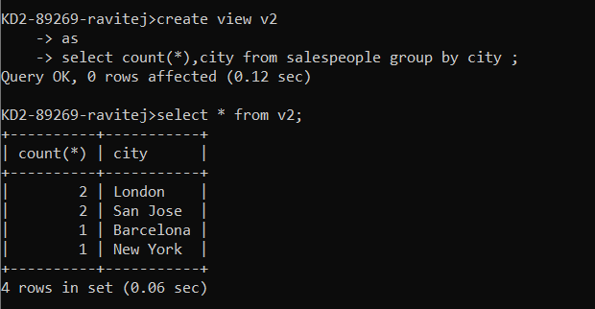

Q3. Create a view that shows the average and total orders for each salesperson after his or her name. Assume all names are unique.

Ans.

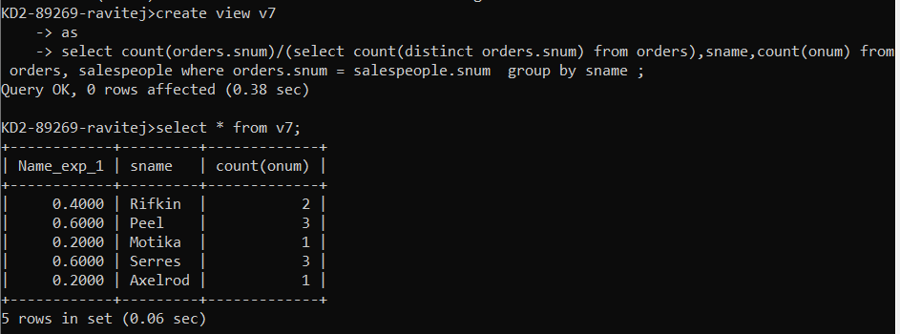

Q4. Create a view that shows each salesperson with multiple customers.

Ans.

