Assignment -6

Create new directory with the name 18oct and create three directories there. (dir1, dir2,
dir3), also create four .txt files (1.txt, 2.txt, 3.txt, 4.txt).


Q. 1. List only directories from 18oct ?

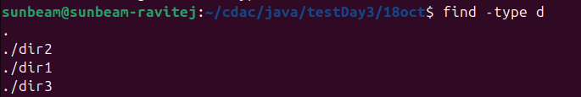
Q. 2. List only files ?
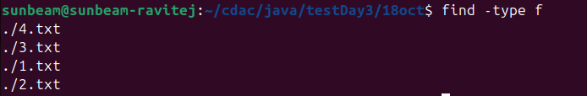
Q. 3. Make 2.txt executable, now search the files having permission as rwxr-xr-x (755) from
18oct ?
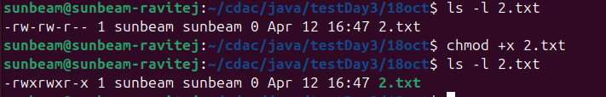
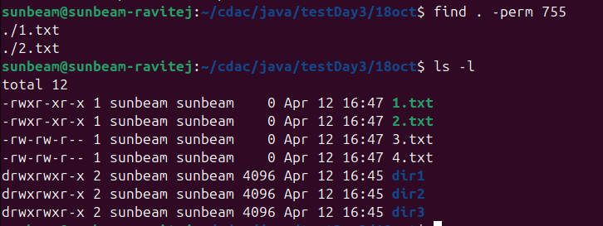

Q. 4. Search the file 4.txt ?

