**Assignment – 1**

**Creating sample tables and inserting values**

Q1. Create the following tables with the given structures and insert sample data as specified: A) SALESPEOPLE

* Snum int(4)
* Sname varchar(10)
* City varchar(10)
* Comm float(3,2)

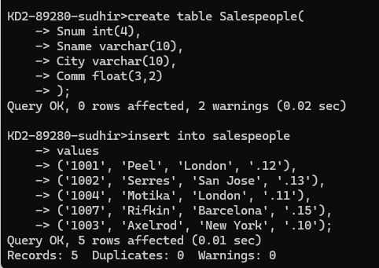Ans.

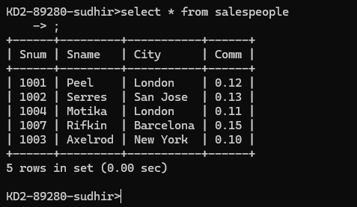

B) CUSTOMERS

* Cnum int(4)
* Cname varchar(10)
* City varchar(10)
* Rating int(4)
* Snum int(4)

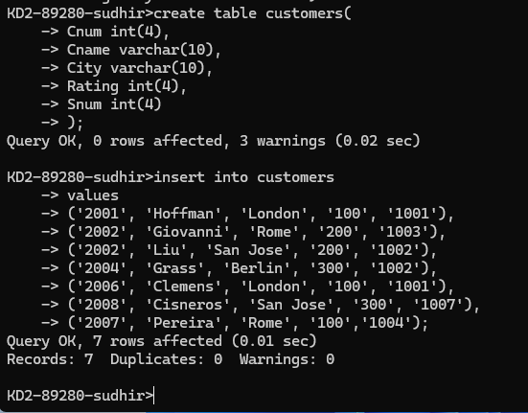Ans.

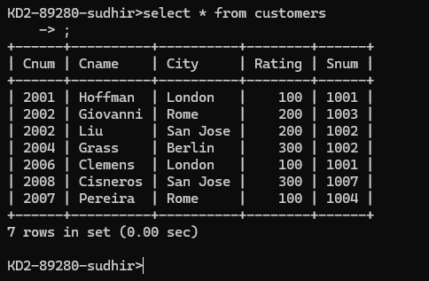

C) ORDERS

* Onum int(4)
* Amt float(7,2)
* Odate date
* Cnum int(4)
* Snum int(4)

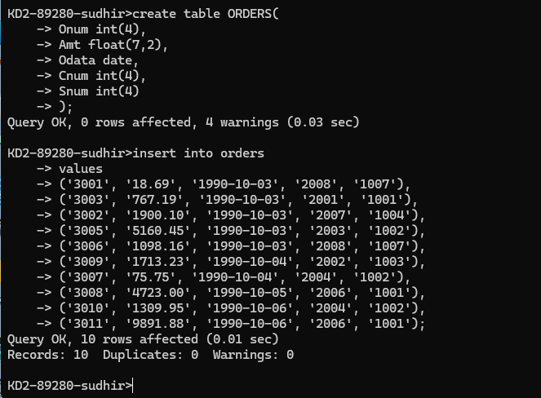Ans.

