**Assignment-11**

**Subqueries**

Q1. Write a query that uses a subquery to obtain all orders for the customer named Cisneros. Assume you do not know his customer number (cnum).

Ans.

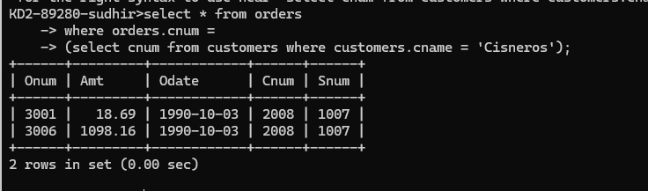

Q2. Write a query that produces the names and ratings of all customers who have above-average orders.

Ans.

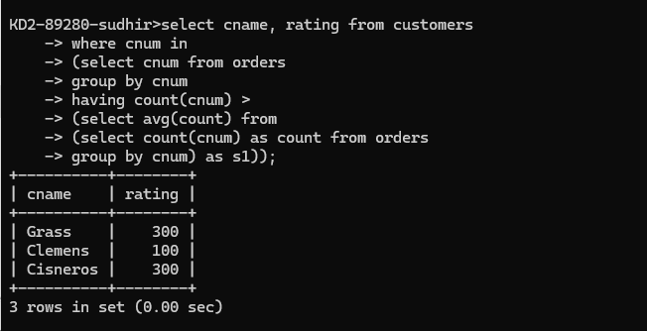

Q3. Write a query that selects the total amount in orders for each salesperson for whom this total is greater than the amount of the largest order in the table.

Ans.

