**Assignment – 14**

**Entering, Deleting, and Changing Field Values.**

Q.1) Write a command that puts the following values, in their given order, into the salespeople table: city – San Jose, name – Blanco, comm – NULL, cnum – 1100?

Ans. 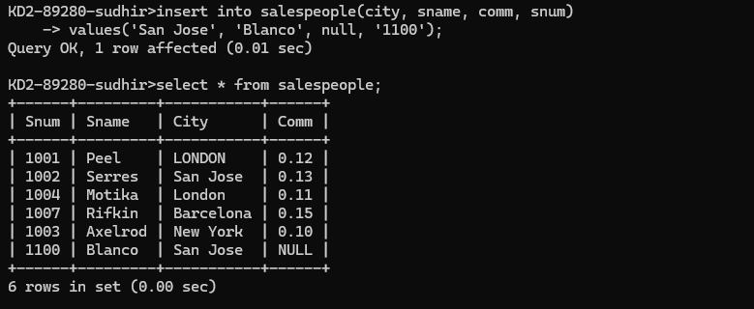

Q.2) Write a command that removes all orders from customer Clemens from the Orders table?

Ans. 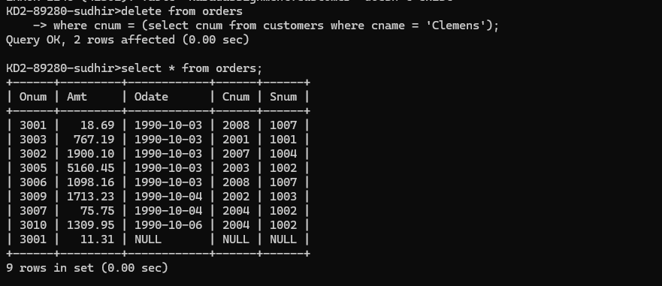

Q.3) Write a command that increases the rating of all customers in Rome by 100?

Ans. 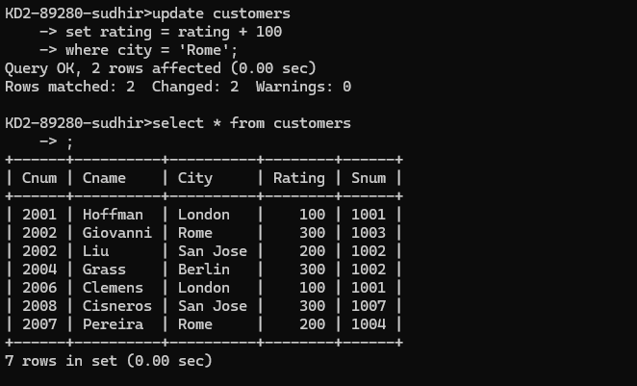

Q.4) Salesperson Serres has left the company. Assign her customers to Motika?

Ans. 