**Assignment –5**

**Relational and Logical Operators.**

Q.1) Write a query that will give you all orders for more than Rs. 1,000?

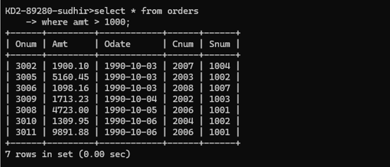Ans.

Q.2) Write a query that will give you the names and cities of all salespeople in London with a commission above .10?

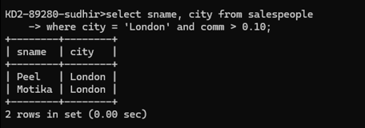Ans.

Q.3) Write a query on the Customers table whose output will exclude all customers with a rating <= 100, unless they are located in Rome?

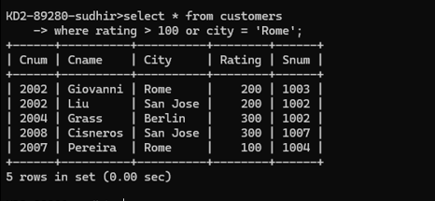Ans.

Q.4) What will be the output from the following query?

Select * from Orders

where (amt < 1000 OR

NOT (odate = ‘1990-10-03’

AND cnum > 2003));

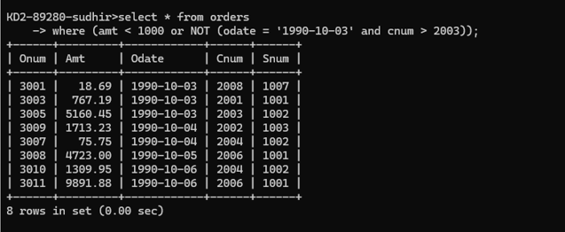Ans.

Q.5) What will be the output of the following query?

Select * from Orders

where NOT ((odate = ‘1990-10-03’ OR snum

>1006) AND amt >= 1500);

Ans.

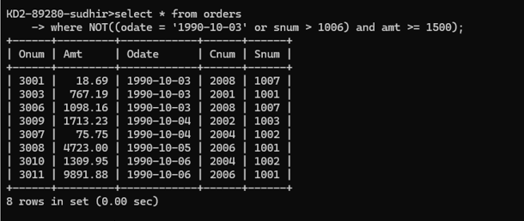

Q.6) What is a simpler way to write this query?

Select snum, sname, city, comm From Salespeople

where (comm > .12 OR comm <.14);

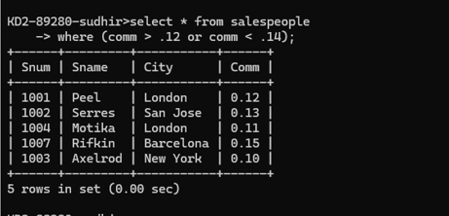Ans.